

**MAHARASHTRA STATE BOARD OF TECHNICAL EDUCATION, MUMBAI**

**“ A holistic approach to campus recruitment and student profile analysis for placement. ”**

**A Project Report**

**Submitted by:**

|  |  |  |
| --- | --- | --- |
| **Sr. No.** | **Name of Student** | **Exam Seat No.** |
| **1)** | **Dhakane Aditya Arun** | **: 400463** |
| **2)** | **Bangar Kalyani Hemant** | **: 400455** |
| **3)** | **Gaidhani Shraddha Punjaram** | **: 400467** |
| **4)** | **Salunke Ashwini Ashok** | **: 400498** |

In partial fulfillment for the award of the Diploma Engineering

in the course Computer Technology at



**Department of Computer Technology**

**K. K. WAGH POLYTECHNIC, NASHIK**

**Academic Year 2023-24**



**MAHARASHTRA STATE BOARD OF TECHNICAL EDUCATION, MUMBAI**

**A**

**Project Report**

**on**

**“ A holistic approach to campus recruitment and student profile analysis for placement. ”**

***Submitted by:***

|  |  |  |
| --- | --- | --- |
| **Sr. No.** | **Name of Student** | **Exam Seat No.** |
| **1)** | **Dhakane Aditya Arun** | **: 400463** |
| **2)** | **Bangar Kalyani Hemant** | **: 400455** |
| **3)** | **Gaidhani Shraddha Punjaram** | **: 400467** |
| **4)** | **Salunke Ashwini Ashok** | **: 400498** |

***Under the Guidance of:***

**Name of Guide: Mr. S.H.Sangale**

**Designation : Lecturer in Computer Technology**



**Department of Computer Technology**

**K. K. WAGH POLYTECHNIC, NASHIK**

**Academic Year 2023-24**

K. K. Wagh Education Society’s

**K. K. WAGH POLYTECHNIC**

HirabaiHaridasVidyanagari, Amrutdham, Panchavati, Nashik-422003, Maharastra

|  |  |  |
| --- | --- | --- |
|  | ***Certificate*** |  |

This is certify that :

|  |  |  |  |  |
| --- | --- | --- | --- | --- |
| ***Sr. No.*** | ***Name of Student*** | ***Class*** | ***Enrolment No.*** | ***Exam Seat No.*** |
| 1 | Dhakane Aditya Arun | TYCM-Lin | 2100780086 | 400463 |
| 2 | Bangar Kalyani Hemant | TYCM-Lin | 2100780078 | 400455 |
| 3 | Gaidhani Shraddha Punjaram | TYCM-Lin | 2100780090 | 400467 |
| 4 | Salunke Ashwini Ashok | TYCM-Lin | 2100780128 | 400498 |

From the institute - K. K. Wagh Polytechnic, Nashik has completed the Project (Capstone Project Planning and Execution (CPE)) for their final year having title **A holistic approach to campus recruitment and student profile analysis for placement.** during the Academic Year 2023-24 in the partial fulfillment of Diploma in Computer Technology. The project is completed by in a group consisting of 4 persons under the guidance of the Faculty Guide.

*Date : 25/03/2024*

*Place : Nashik*

Mr. S.H.Sangale Prof.G. B. Katkade

*Internal Faculty Guide* *HOD- Computer Technology*

(Sign of Mentor from the Institute) Prof. P. T. Kadave

Name: Mr. S. H. Sangale *Principal – K. K. Wagh* Designation: Lecturer in Computer Technology *Polytechnic, Nashik*

Contact: 7709187681

Email ID : shsangale@kkwagh.edu.in

**Sponsor’s Certificate- r3sys**



**Project Competition Participation Certificate(s) by the SNJB`s Polytechnic, Chandwad**

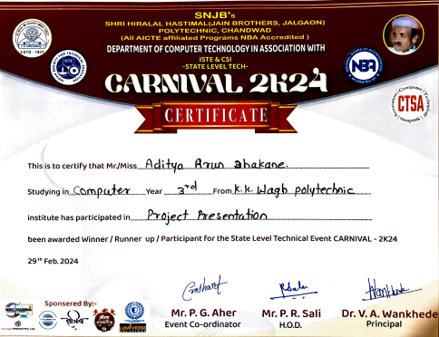

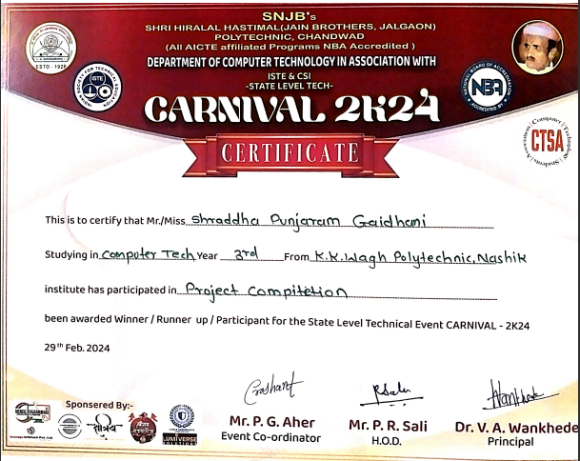

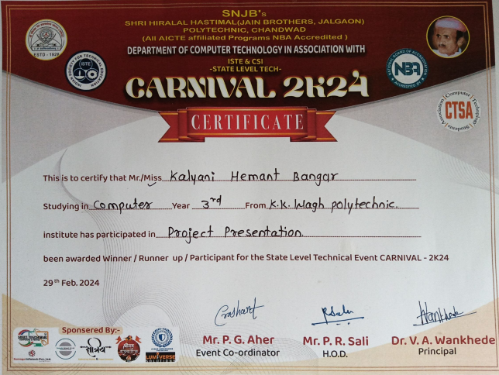

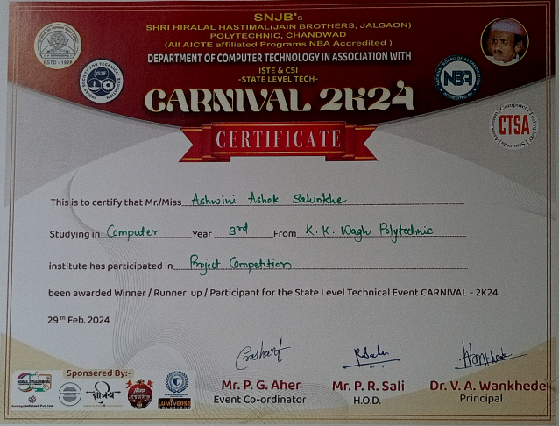

**Paper Publication Certificate(s) by the International Journal For Multidisciplinary Research**

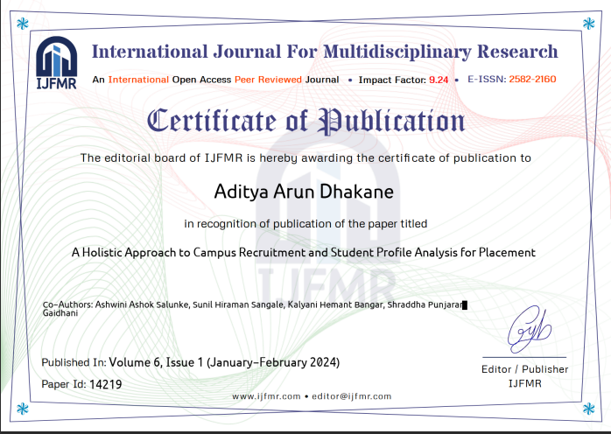

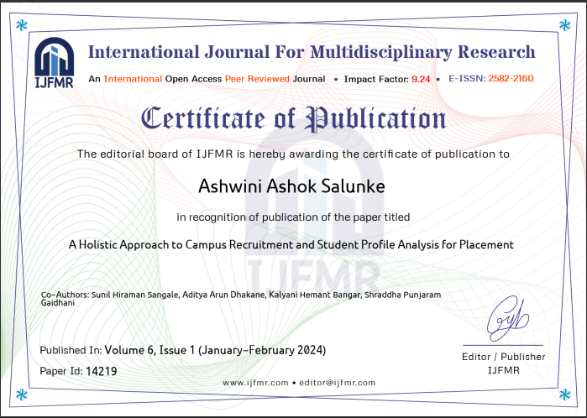

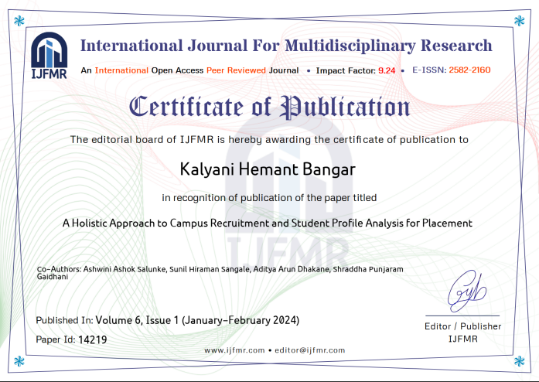

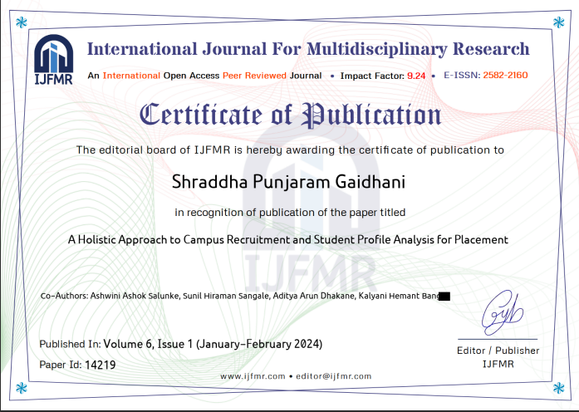

#### **acknowledgement**

With deep sense of gratitude we would like to thanks all the people who have lit our path with their kind guidance. We are very grateful to these intellectuals who did their best to help during our project work.

It is our proud privilege to express deep sense of gratitude to, Prof. P. T. Kadave, Principal, K.K.Wagh Polytechnic, Nashik for his comments and kind permission to complete this project. We remain indebted to Prof. G.B. Katkade, Head of Computer Technology Department for his timely suggestion and valuable guidance.

The special gratitude goes our external guide **Mr.P.M.Mohan**, TPO Officer at our **Institute Sponsor**: K.K.Wagh Polytechnic Nashik for their sponsorship permissions and directions for our project selection and implementations. We are greateful and remain indebt to our Internal Guide **Mr. S.H.Sangale** for his consistent instructions, guidance for the completion of project.

We are thankful to all Faculty members, Technical staff members of Computer Technology Department for their expensive, excellent and precious guidance in completion of this work. We thanks to all the class colleagues for their appreciable help for our working project.

With various industry owners or lab technicians to help, it has been our endeavor to through out our work to cover the entire project work.

We also thankful to our parents who providing their wishful support for our project completion successfully.Lastly we thanks to our all friends and the people who are directly or indirectly related to our project work.

**Names of Students Class**

1) Dhakane Aditya Arun TYCM-Lin

2) Bangar Kalyani Hemant TYCM-Lin

3) Gaidhani Shraddha Punjaram TYCM-Lin

4) Salunke Ashwini Ashok TYCM-Lin

**Vision & Mision**

|  |
| --- |
| **Institute Vision : -**Strive to empower students with Quality Technical Education. |
| **Institute Mission :-** Committed to develop students as Competent and Socially Responsible Diploma Engineers by inculcating learning to learn skills, values and ethics, entrepreneurial attitude, safe and eco-friendly outlook and innovative thinking to fulfill aspirations of all the stakeholders and contribute in the development of Organization, Society and Nation. |
| **Department Vision :-**To impart quality technical education for development of technocrats. |
| **Department Mission :-**  **M1-** To provide quality in education and facilities for students to help them to achieve higher academic career growths.  **M2**- To impart education to meet the requirements of the industry and society by technological solutions.  **M3**- Develop technical & soft skill through co–curricular and extra-curricular activities for improving personality. |
| **Program Educational Objectives:-**  **PEO1:** Provide socially responsible, environment friendly solutions to Computer engineering related broad-based problems adapting professional ethics.  **PEO2:** Adapt state-of-the-art Computer engineering broad-based technologies to work in multi-disciplinary work environments.  **PEO3:** Solve broad-based problems individually and as a team member communicating effectively in the world of work. |
| **Program Specific Outcome:-**(Version – 1.2)  **PSO 1**: **Computer Software and Hardware Usage:** Use state-of-the-art technologies for operation and application of computer software and hardware.  **PSO 2:** **Computer Engineering Maintenance:** Maintain computer engineering related software and hardware systems. |
| **Program Outcomes:-**  **PO1. Basic and Discipline specific knowledge:** Apply knowledge of basic mathematics, science and engineering fundamentals and engineering specialization to solve the engineering problems.  **PO2. Problem analysis:** Identify and analyse well-defined engineering problems using codified standard methods.  **PO3. Design/ development of solutions**: Design solutions for well-defined technical problems and assist with the design of systems components or processes to meet specified needs.  **PO4. Engineering Tools, Experimentation and Testing:** Apply modern engineering tools and appropriate technique to conduct standard tests and measurements.  **PO5. Engineering practices for society, sustainability and environment**: Apply appropriate technology in context of society, sustainability, environment and ethical practices.  **PO6. Project Management**: Use engineering management principles individually, as a team member or a leader to manage projects and effectively communicate about well-defined engineering activities.  **PO7. Life-long learning:** Ability to analyse individual needs and engage in updating in the context of technological changes. |

**ABSTRACT**

The ICRPT (Integrated Campus Recruitment, Placement, and Training Analysis) system is a sophisticated software solution aimed at connecting students with job opportunities and enhancing recruitment processes for organizations. It comprises three main entities: Teachers (TPO), Students, and HR Personnel, each fulfilling specific roles. The system promotes transparency, simplifies data management, and facilitates effective communication between stakeholders. ICRPT features profile management, quiz participation, aptitude testing, vacancy posting, candidate evaluation, and offer letter generation. Leveraging modern web technologies, it provides an intuitive user interface and supports video/audio recording for assessments. With ICRPT, students can enhance their skills, monitor performance, and HR professionals can streamline recruitment processes while gaining insights into candidate suitability. Ultimately, ICRPT bridges the gap between education and industry, fostering employability and growth for both students and organizations.

**Keywords**: *Data-Driven, Recruitment Strategy, Career Readiness, Data Visualization, Transparent Assessments*

**Table of Contents**

|  |  |  |
| --- | --- | --- |
| **Sr. No.** | **Name of Topics** | **Page No.** |
|  | **Certificates** |  |
|  | **Sponsor's Certificate** | IV |
|  | **Achievements/Participation certificate** | V |
|  | **Acknowledgment** | IX |
|  | **Vision and Mission** | X |
|  | **Abstract** | XII |
|  | **Table of contents** | XIII |
| **1** | **Introduction** | 1-6 |
| 1.1. Introduction | 1 |
| 1.2. Overview | 1 |
| 1.3. Problem Definition | 2 |
| 1.4. Motivation | 2 |
| 1.5. Literature Survey | 2 |
| 1.6. Existing Systems | 3 |
| 1.7. Proposed System | 4 |
| 1.8. Features | 5 |
| **2.** | **Analysis and Feasibility** | 7-8 |
| 2.1. Analysis | 7 |
| 2.2. Feasibility Study | 7 |
| **3** | **Project Requirements** | 9-13 |
| 3.1. About Proposed System | 9 |
| 3.2. Area of Implementation | 9 |
| 3.3. Functional Requirements | 10 |
| 3.4. Non-functional Requirements | 12 |
| 3.5. Hardware Requirements | 13 |
| 3.6. Software Requirements | 13 |
| **4.** | **Project Design and Implementation** | 14-34 |
| 4.1. Design Concept | 14 |
| 4.2 System Architecture | 14-15 |
| 4.3 DFD Diagram | 16-19 |
| 4.4.UML Diagram | 19-21 |
| 4.5 Activity Diagram | 22-24 |
| 4.6 Class Diagram | 24-25 |
| 4.7 State Chart Diagram | 25-26 |
| 4.8 Deployment Diagram | 26 |
| 4.9 Sequence Diagram | 27 |
| 4.10 Module analysis | 28-30 |
| 4.10.1 Module | 28 |
| 4.10.2 Purpose of Module | 28 |
| 4.10.3 Algorithm | 30-31 |
| 4.11.4 Flowchart | 31-34 |
| **5** | **Results and Screenshots** | 35-45 |
| **6** | **Testing** | 46-52 |
| **6.1. Introduction of testing** | 46 |
| **6.2. Objectives of Testing** | 46 |
| **6.3. Test Cases.** | 46-51 |
| **6.4. Non Functional Testing Test Cases** | 51-52 |
| **7** | **Cost Estimation.** | 53-55 |
| **8** | **Applications** | 56-57 |
| **9** | **Future scope** | 58-59 |
| **10** | **Conclusion** | 60 |
| **11** | **References** | 61 |
| **12** | **Published or Presented Papers** | 62 |

**Index of Figures**

|  |  |  |
| --- | --- | --- |
| Fig. No. | Name of Figure | Page no. |
| 4.1 | System Architecture. | 14-15 |
| 4.2.1 | Data Flow Diagram: level 0 | 16 |
| 4.2.2 | Data Flow Diagram: level 1 | 16 |
| 4.2.3 | Data Flow Diagram: level 2 | 17-19 |
| 4.3.1 | Use Case Diagram | 19-21 |
| 4.3.2 | Class Diagram | 24-25 |
| 4.3.3 | Activity Diagram | 22-24 |
| 4.3.4 | Deployment Diagram | 26 |
| 4.4 | Sequence Diagram | 27 |
| 4.5 | State Chart Diagram | 25-26 |
| 4.6 | Flow Chart | 31-34 |

**Index of Tables**

|  |  |  |
| --- | --- | --- |
| **Tab. No.** | **Title of Table** | **Page no.** |
| 3.1 | Function Requirements. | 10 |
| 3.2 | Hardware Requirements. | 13 |
| 3.3 | Minimum Requirements. | 13 |
| 3.4 | Software Requirements. | 13 |
| 3.5 | Project Operation Requirements | 13 |
| 6.1 | Admin Modules Test Cases. | 46-48 |
| 6.2 | HR(Company) Module Test Cases. | 48-50 |
| 6.3 | Student Module Test Cases. | 50-51 |
| 6.4 | Function Testing. | 50-51 |
| 6.4 | Non-Functional Testing. | 51-52 |
| 12.1 | List of Published/Presented papers/ Competition. | 62 |

**CHAPTER – 1 : INTRODUCTION**

* 1. **Introduction**

A holistic approach to campus recruitment and student profile analysis is essential in today's competitive landscape, bridging academia and industry seamlessly. Traditional methods, focusing solely on academic achievements, often overlook vital aspects of a student's potential. By embracing proactive engagement, technology-driven recruitment, and comprehensive profile evaluation, this approach ensures a more inclusive and effective recruitment process. It considers not only academic performance but also extracurricular involvement, soft skills, and career aspirations, fostering better matches between candidates and employers while enhancing students' career prospects.

This comprehensive strategy emphasizes personalized guidance, mentorship, and the recognition of diverse skills and experiences. By addressing the limitations of traditional approaches, such as bias and limited candidate pools, organizations can tap into a broader talent pool and nurture future leaders effectively. Through collaborative programs, data-driven insights, and continuous feedback analysis, a holistic approach empowers both students and employers, enriching the campus recruitment experience and driving long-term success for all stakeholders.

* 1. **Overview**

In a world where the job market is constantly evolving at a rapid pace, the alignment between education and industry stands as a pivotal concern. Educational institutions today are entrusted with the responsibility of preparing students not only with the foundational knowledge but also with the practical skills necessary to thrive in their chosen careers. Simultaneously, organizations are on the hunt for the most qualified and competent candidates who can seamlessly integrate into their dynamic and everevolving workforce.

However, despite the shared goal of preparing students for the workforce, the transition from academia to the professional world is often marked by numerous challenges for both students and employers. Graduates may find it challenging to translate their educational experiences into practical job skills, and employers may struggle to identify the most suitable candidates who align with their evolving needs and industry demands. To address these intricate challenges and to foster a harmonious connection between students and potential employers, we are proud to introduce the "Integrated Campus Recruitment, Placement, and Training Analysis" (ICRPT) system. Developed with the specific needs and aspirations of our college students in mind, ICRPT represents a cuttingedge solution designed to bridge the gap between the academic realm and the professional landscape. With ICRPT, we embark on a journey to revolutionize the way our students prepare for their future careers and how employers identify the bestfit talent.

This innovative system leverages the power of data-driven analysis, comprehensive student profiling, and a holistic approach to campus recruitment, placement, and training. It not only helps students gain a clearer understanding of their strengths, weaknesses, and career potential but also empowers our institution to tailor educational experiences that align with the demands of the job market. On the employer's side, ICRPT streamlines the recruitment process by offering insights into the most promising talent pool among our students, thereby saving valuable time and resources. With ICRPT, we embark on a transformative journey that puts our students at the forefront of industry readiness and ensures that the knowledge and skills they acquire during their time at our college are directly applicable in their future careers. We invite you to explore this dynamic system and join us in shaping a brighter and more prosperous future for our students and the organizations that seek their talents. This innovative system represents a pivotal shift in the way we prepare and connect

our students to the professional world. It's a strategic move towards nurturing well-rounded, job-ready graduates who are not just academically accomplished but also equipped with the skills and insights needed to thrive in today's competitive job market. Through this system, we reaffirm our commitment to empowering students and ensuring the long-term success of our educational institution.

* 1. **Problem Defination**

The task is to design and develop a Training and Placement Application that streamlines the process of connecting job seekers (students or candidates) with potential employers (companies) while providing comprehensive support for skill development, job search, and placement activities.

* 1. **Motivation**

Aim of the Training and Placement Application is to bridge the gap between job seekers and employers, making the job search and placement process more efficient, effective, and user-friendly. It strives to empower individuals with the tools and opportunities to advance their careers while helping companies find the right talent for their needs.

**1.5 Literature Survey**

The analysis in this paper, The main goal is to narrow or close the growing gap between students and the job market. The research looks at various job training programs offered on college campuses in an effort to shape our students into marketable human resources. The article also seeks to figure out how students should be actually encouraged to apply the lessons learned on college campuses to actual placement. it is helpful to have the most recent information on the companies visiting the campus. Analyzing the students strength and weakness in order to develop a commitment that will be effective for the educational institutions training and placement activities based on the students query specific report for various companies recruiting.[1]

The placement of a student on campus has a big impact on a college. Companies visit colleges during campus placement to identified qualified candidates before they graduate. The most important factors for successful placement can be found by analyzing patterns and qualities in the massive volumes of student’s information that schools retain. It is possible to predict the placement of engineering students starting from their second year. which can aid in the student’s correct development. Students could be provided access to an interface facilitating the submission of applications to multiple businesses in just one click. Obviating the need to update information that is already in the system. This can cut-down on the time and work needed to verify the information given by the pupils.[2]

Predictive analytics, employing machine learning classification algorithms, are utilized to assess the probability of placement within specific industries like fintech, startups, and products/services. Additionally, it can identify key characteristics that influence a candidate’s chance of landing a job in that industry, benefiting both the college and the student. [3]

**1.6 Existing System**

In the existing system,All processes are handled manually. All the work that is done inthe existing system is done by the human intervention .As all the work is donemanually, there were a lot of workload on placement officer and it also increases themaximum chances of errors. This is so slow and time consuming. Due to increase innumber of user’s the process become more difficult.

Problems faced in existing system are as follows-

1. **Manual Eligibility Assessment:**

* The TPO manually searches for eligible students based on company criteria.
* This process is time-consuming and prone to human error.

1. **Data Management Challenges:**

* Records are stored in modified Excel sheets, exacerbating sorting issues.
* Data redundancy is common due to the duplication of records.

1. **Manual Information Organization:**

* TPOs manually collect and organize student information and resumes.
* Sorting is done according to various streams, adding to the administrative burden.

1. **CV Collection and Handling:**

* Collecting CVs from numerous students is laborious and time-consuming.
* Managing a large volume of CVs poses a significant overhead for TPOs.

1. **Inefficient Communication:**

* Informing specific students about company criteria is time-consuming.
* The process of managing, updating, and informing students is resource-intensive and inefficient.

**1.7 Proposed System**

The proposed ICRPT project is a robust software solution designed to streamline campus recruitment by integrating educational institutions, students, and employers. This comprehensive system acts as a centralized platform, prioritizing features such as skills enhancement, job provision, and recruitment guidance. It employs modern web technologies to ensure security and integrity, incorporating functionalities for assessments. The system comprises key modules tailored to specific user roles: Teacher (TPO), Student, and HR. TPOs manage student profiles, job postings, and analytics for performance evaluation. Students utilize the platform to create detailed profiles, apply for jobs, and track application statuses. HR personnel are equipped to create and manage company profiles, post job openings, review applications, and provide feedback, thereby ensuring efficient recruitment processes. The application design emphasizes seamless interaction between modules to facilitate effective communication and successful job placements.

Solution to the challenges faced in the existing system are as follows-

1. **Manual Eligibility Assessment:**

* **Solution:** Automation matches student profiles with company criteria, reducing manual intervention by TPOs.

1. **Data Management Challenges:**

* **Solution:** Robust database management minimizes redundancy, ensuring secure and organized storage of records.

1. **Manual Information Organization:**

* **Solution:** Intuitive tools categorize student data for efficient retrieval, streamlining candidate selection.

1. **CV Collection and Handling:**

* **Solution:** Students upload resumes directly onto the platform, simplifying collection and parsing for HR review.

1. **Inefficient Communication:**

* **Solution:** Targeted notifications and real-time messaging facilitate seamless communication between stakeholders.
  + 1. **Objectives**

The objectives are as follows:

* 1. To engage with colleges and universities at an early stage to build a strong brand reputation, increase visibility, and attract top talent from campuses.
  2. To conduct regular campus visits to interact with students, faculty, and placement cells, understand the student profile, and identify potential candidates.
  3. To collaborate with colleges and universities to offer internships, projects, and training programs to students, which can help them develop the required skills and make them more attractive to organizations.
  4. To adopt technology-enabled recruitment solutions that can provide a seamless candidate experience, reduce recruitment costs, and improve efficiency.
  5. To collect data on student profiles, skills, preferences, and feedback through various sources such as college databases, online platforms, and surveys.
  6. To conduct skills assessment tests to evaluate the skills of candidates and identify areas where they need improvement.
  7. To assess the cultural fit of candidates by understanding their values, beliefs, and preferences.
  8. To analyze feedback from candidates at every stage of the recruitment process to identify areas for improvement and make necessary changes.
  9. To build a strong talent pipeline by identifying potential candidates early on, nurturing them through collaborative programs, and providing them with opportunities for growth and development within the organization.
  10. To provide a positive candidate experience by adopting a proactive, integrated, and data-driven approach that focuses on early engagement, regular campus visits, collaborative programs, technology-enabled recruitment, skills assessment, cultural fit assessment, feedback analysis, and talent pipeline development.
      1. **Area of Project**

Web Development in Educational Institutions and Industrial Sectors

* + 1. **Features**

1. **Integrated Recruitment Strategies:** Implement a diverse range of strategies including on-campus job fairs, online portals, and targeted marketing to attract suitable candidates.
2. **Comprehensive Profile Analysis:** Analyze students' complete profiles, encompassing academic performance, extracurriculars, internships, and skills beyond academic qualifications.
3. **Soft Skills Development:** Conduct workshops and training programs to enhance essential soft skills like communication and teamwork.
4. **Industry-Academia Collaboration:** Foster partnerships between educational institutions and industries through research projects, guest lectures, and internships.
5. **Continuous Feedback Mechanism:** Gather feedback from recruiters and students to refine the recruitment process and stay updated with industry trends.
6. **Data-Driven Decision-Making:** Utilize analytics to make informed decisions based on placement trends, student preferences, and industry requirements.
7. **User Authentication and Authorization:** Secure login and role management for students, TPOs, and HR professionals.
8. **Student Profile Management:** Maintain comprehensive student profiles, including personal, academic, and skill information.
9. **Job Posting and Management:** Facilitate the posting, updating, and removal of job vacancies by HR professionals.
10. **Communication:** Enable communication between students and HR via messaging and email alerts for job openings.
11. **Skill Assessment:** Offer skill assessment tests or quizzes for students to showcase their expertise.
12. **Job Matching Algorithm:** Match students with jobs based on skills and preferences.
13. **Resume Upload:** Allow students to upload resumes for easy viewing by employers.
14. **Analytics and Reporting:** Track applications, view metrics, and assess recruitment effectiveness.
15. **Job Application Tracking:** Enable students to track application statuses.
16. **Candidate Selection Notification:** Automatically notify selected candidates and inform others of their status.
17. **Long-Term Relationship Building:** Focus on building enduring relationships between institutions, recruiters, and students to provide ongoing support and progression opportunities.
18. **Regular Monitoring and Evaluation:** Establish systems for monitoring and evaluating the effectiveness of recruitment strategies and adapting to market dynamics.

**CHAPTER – 2 : ANALYSIS AND FEASIBILITY**

1. **Analysis**

System analysis serves as a cornerstone for problem-solving, where understanding existing issues, defining objectives, and evaluating potential solutions are paramount. It integrates organizational needs with technological solutions, with feasibility studies providing crucial guidance for design and development.

Effective technical analysis is imperative for optimizing system performance and ensuring seamless integration with existing infrastructure. This involves considering hardware requirements, software compatibility, and user skill levels.

* **System Improvements:** All proposed changes aim to increase efficiency and improve customer service. Positive impacts on operational workflows and service quality are anticipated, aligning with organizational goals for enhanced productivity and customer satisfaction.
* **Required Skills:** The project utilizes widely adopted platforms and tools, assuming no specialized skills are necessary for implementation and operation. This accessibility ensures ease of adoption and maintenance, minimizing barriers to entry and facilitating widespread utilization.
* **Acceptability:** The system's structure is designed with user experience in mind, prioritizing simplicity and intuitiveness. Anticipated user acceptance is high, driven by the system's intuitive design and user-friendly interface. By addressing usability concerns proactively, the system aims to streamline adoption and maximize user satisfaction.

1. **Feasibility Study**

A feasibility study is an essential part of the preliminary investigation, assessing costs and benefits to recommend actionable steps based on operational, technical, economic, and time considerations. Its primary goal is to determine if the system request warrants further exploration.

1. **Technical Feasibility:**

The proposed system's development is economically viable, leveraging existing resources to eliminate manual processes and enhance accuracy. Utilizing widely adopted platforms and tools, such as Netbean 8, Apache Tomcat 8.0, MySQL 5.0, and Android Studio, ensures efficiency and error-free operation. Additionally, employing a network of central active hubs with passive nodes optimizes functionality and ease of use.

1. **Economic Feasibility:**

Economic analysis reveals that the development cost of the system, utilizing freely available software like Netbean 8, Android Studio, and MySQL, is minimal. The benefits include reduced labor expenses and manual paperwork, making it a cost-effective solution for organizations.

1. **Operational Feasibility:**

The proposed system is operationally workable, featuring user-friendly modules with intuitive GUIs for administrators, users, and teachers. Basic computer and internet knowledge suffice for system operation, ensuring accessibility. Live web-based access requires internet connectivity, further enhancing operational feasibility and user convenience.

1. **Behavioural Feasibility:**

Anticipated user acceptance is high, given the intuitive design and simplicity of the system's structure. The interface is designed to minimize usability concerns, facilitating smooth adoption and operation.

* **Conclusion:**

Overall, the proposed system demonstrates strong technical, economic, operational, and behavioural feasibility, making it a viable solution for addressing organizational needs effectively. By leveraging existing technologies and incorporating user-friendly design principles, the system promises to enhance efficiency, accuracy, and user satisfaction.

**CHAPTER – 3 : PROJECT REQUIREMENTS**

1. **About Proposed Project**

The proposed ICRPT project represents a robust software solution engineered to revolutionize the campus recruitment landscape. By seamlessly integrating educational institutions, students, and prospective employers, this comprehensive system streamlines every facet of the recruitment process. Serving as a centralized platform, it offers a plethora of features meticulously crafted to elevate student skills, furnish abundant job opportunities, and provide steadfast guidance from application to placement.

Leveraging cutting-edge web technologies, the system prioritizes data security and integrity, incorporating advanced functionalities such as video and audio recording for assessments, ensuring a seamless and reliable user experience. At its core are key modules tailored to the specific needs of stakeholders: the Teacher (TPO), Student, and HR modules.

The TPO module empowers Training and Placement Officers to efficiently manage student profiles, post job openings, and engage in direct communication with students. Furthermore, TPOs gain access to comprehensive analytics for in-depth performance evaluation.

For students, the system offers a user-friendly interface to create and manage detailed profiles, seamlessly apply for jobs, track application statuses, and optionally participate in skill assessments to showcase their capabilities effectively.

HR personnel benefit from robust tools to create and manage company profiles, effortlessly post job openings, review applications, and provide constructive feedback, thereby ensuring swift and efficient recruitment processes.

The application design underscores seamless interaction between modules, facilitating effective communication and maximizing the likelihood of successful job placements. With its holistic approach and innovative features, the proposed ICRPT system sets a new standard for campus recruitment solutions, promising unparalleled efficiency, transparency, and effectiveness for all stakeholders involved.

1. **Area of Implementation**

In the ICRPT project, the utilization of the Naive Bayes algorithm, particularly in classifying and predicting student profiles based on the Big Five personality traits, enhances the precision and efficiency of student profile analysis. This enables institutions to predict job prospects, identify strengths and weaknesses, and offer personalized career guidance, thereby improving the effectiveness of the recruitment process.

1. **Functional Requirements**

|  |  |  |  |  |
| --- | --- | --- | --- | --- |
| **Sr. no** | **Functions** | **Input** | **Process** | **Output** |
| 1 | Candidate  Registration | Candidate detail (name, email, password) | Verify and store information | Confirmation message,  Candidate profile |
| 2 | Company  Registration | Company details ( name, email, password) | Verify and store company information | Confirmation message,  Company profile |
| 3 | Company job  posting | Job related details | Post job listing to the platform. | Post job list |
| 4 | Job matching | Candidate profile, job requirements | Match candidate to job opening based on skills and criteria. | List of matching job opening. |
| 5 | Skill assessment | Candidate skills  test | Evaluate candidate skills based on assessment | Skill assessment result |
| 6 | Submit job application and track  status | Job application details | Store application to the candidate and posting. Display the status of job application  (received, in progress, waiting, rejected) | Confirmation of application submission. Status of application |

Table 3.1 Functional Requirements

**System Description:**

S= I, O,F,DD,NDD, Failure, Success

Where,

S=System

I= Input

O=Output

F=Failure

S=Success

I is Input of system

Input I = set of Inputs

Where,

I= {I1,I2 ,I3,I4}

Where,

I1={ Admin}

I2= {HR}

I3= { Company }

I4={Students}

F is Function of system

F = set of Function

Where,

F1={Login }

F2={Approve /View Students}

F3={Add/View/Delete Company}

F4={Add/View/Delete job related post}

F5={Conduct Quiz(OCEAN)}

F6={ View Assessment Score}

F7={View Top Candidate}

F8={Result declare(Email send)}

F9={Track Status of Placement}

F10={ Create Profile}

O is Output of system

Output O= {O1 }

O1 = {A Holistic Approch To Campus Recruitment AndStudent Profile Analysis For Placement}

* Success Conditions: Product working Smoothly.DevelopA HolisticApproch To Campus Recruitment AndStudent Profile Analysis For Placementis successfully.
* Failure Conditions: if internet connection Unavailable.

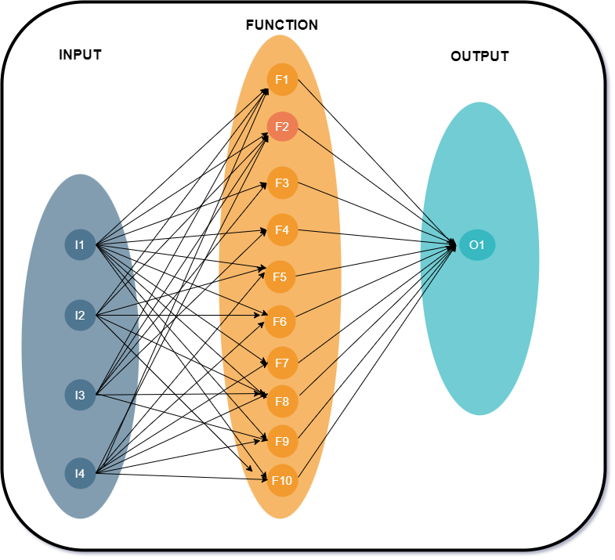**VENN DIAGRAM:**

Fig.3.1 Venn Diagram

**FUNCTIONAL DEPENDANCY DIAGRAM**

A set of Functional Dependencies for a data model can be documented in a Functional Dependency Diagram (also known as a Determinancy Diagram). In a Functional Dependency Diagram each attribute is shown in a rectangle with an arrow indicating the direction of the dependency.

|  |  |  |  |  |  |  |  |  |  |  |
| --- | --- | --- | --- | --- | --- | --- | --- | --- | --- | --- |
|  | **F1** | **F2** | **F3** | **F4** | **F5** | **F6** | **F7** | **F8** | **F9** | **F10** |
| **F1** | 1 | 0 | 0 | 0 | 0 | 0 | 0 | 0 | 0 | 0 |
| **F2** | 0 | 1 | 0 | 0 | 0 | 0 | 0 | 0 | 0 | 0 |
| **F3** | 0 | 0 | 1 | 0 | 0 | 0 | 0 | 0 | 0 | 0 |
| **F4** | 0 | 0 | 0 | 1 | 0 | 0 | 0 | 0 | 0 | 0 |
| **F5** | 0 | 0 | 0 | 0 | 1 | 0 | 0 | 0 | 0 | 0 |
| **F6** | 0 | 0 | 0 | 0 | 0 | 1 | 0 | 0 | 0 | 0 |
| **F7** | 0 | 0 | 0 | 0 | 0 | 0 | 1 | 0 | 0 | 0 |
| **F8** | 0 | 0 | 0 | 0 | 0 | 0 | 0 | 1 | 0 | 0 |
| **F9** | 0 | 0 | 0 | 0 | 0 | 0 | 0 | 0 | 1 | 0 |
| **F10** | 0 | 0 | 0 | 0 | 0 | 0 | 0 | 0 | 0 | 1 |

Table 3.1 Functional Dependancy Diagram

1. **Non-Functional Requirements**
2. **Performance:**

The system should response quickly to user action. System must handle a growing number of users, job listing and messages without significant degradation in performance. It should be able to handle peak loads, especially during job posting period, without crashing or slowing down.

1. **Security:**

Protect user data, including personal information, resumes and messages through encryption and data security. Assign roles and permissions to control who can access, modify or delete data.

1. **Usability:**

The user interface must be intuitive, accessible and user friendly.

1. **Compatibility:**

Ensure the application work consistently across various web broowsers(eg. Chrome, firefox, safari). The mobile web platform should function well on different operation systems(eg. iOS, Android).

1. **Hardware requirements:**

#### For Development:

|  |  |  |
| --- | --- | --- |
| **S. No.** | **Hardware** | **Specifications** |
| 1) | Processor | Intel Core i3 + |
| 2) | RAM | 4 GB |
| 3) | Storage | 512 GB SSD |

Table 3.2 Hardware Requirements

* For Use:

|  |  |  |
| --- | --- | --- |
| **S. No.** | **Hardware** | **Specifications** |
| 1) | Processor | Intel Core i3 or above |
| 2) | RAM | 4 GB or above |
| 3) | Storage | More than 20 GB or more |
| 4) | Other Hardware | Network Interface Card (NIC) mouse, keyboard and monitor, etc |

Table 3.3 Minimum Requirements

1. **Software Requirements**

#### For Development:

|  |  |  |
| --- | --- | --- |
| **S. No.** | **Software** | **Operation** |
| 1) | XAMPP Server | 8.2.12 |
| 2) | Eclipse IDE | 4.30.0 stable |
| 3) | Operating System | Windows 10+ |

Table 3.4 Software Requirements

#### For Project Operation:

|  |  |  |
| --- | --- | --- |
| **S. No.** | **Software** | **Operation** |
| 1) | Browser | Google Chrome, Mozilla Firefox, Microsoft Edge,Safari,etc., |
| 2) | Operating System | Windows 10+ |

Table 3.5 Software Project Operation Requirements

**CHAPTER – 4 : PROJECT DESIGN AND IMPLEMENTATION**

1. **Design Concept**

Year planner chart is also called as time line chart. Time line chart is use for proper scheduling of project. A timeline chart can be developing for entire project. Alternately separate time line chart is developing for each function. A time line chart enables what task will be conducted at given point of time. The task set that is selected is collection of software engineering work task, milestone and deliverable that must be to complete a particular project. In timeline chart all project task are listed in left-hand column. The horizontal bar indicates duration of each task. When multiple bars occur at the same time, task concurrency is implied. The diamond indicates milestones. Time line chart help to determine how each task is initiated in addition it gives the understanding of priority and criticality of each task. When force with serve deadline pressures, a

project scheduling technique called Time-Boxing is used. Time line plan is use for correct setting up of project. A timeline chart can be rising for entire project. Alternately divide time line chart is on the rise for each function. Year Planner enables you to create a structured and renewed Year Plan of your project. It is designed to help you identify the project's goals and outlines the analysis, strategies and planning required for these goals to be achieved. The Year Planner allows you to create a yearly plan for your project. Here you are able to outline what you want your project to achieve during the year ahead. Therefore, you are able to stay focused on the big picture and will not get lost in the detailed day-to-day planning. It also reduces risks and increases the chances of success for your project.

1. **System Architecture**

Following figure explains the working of the proposed system. Next, The ICRPT Application represents the core software system. Users interact with the application through different modules, including the "Student Module," Admin Module, and HR Module.

The Core System Features encompass essential functionalities of ICRPT, including user profiles, job posting, assessments, comparison tools, notifications, data management, security, reporting, and analytics.

* **Teacher(TPO) :** Teacher can create and manage students profiles. They can also post job related information. Teacher can communicate with students to provide guidance, feedback, or additional information regarding job placements. Access to analytics and reports related to student performance, job placement and the effectiveness of their recommendations.
* **Student:** Students can create detailed profiles, including their education history, skills, achievements and career aspirations. Access to job listings posted by teachers or HR personnel. Students can apply for jobs, track application statuses. They can also receive updates on application statuses, interview invitations and other relevant information. Optional assessments or quizzes to evaluate and show their skills.
* **HR:** HR personnel can create and manage company profiles including company information job listing and contact details & post job opening for students to apply. view and manage application from students including reviewing resume and profile. They can also communicate with students and teachers regarding job listing and selection processes. Provide feedback on the platform usability and the quality of candidates

The application design should ensure a seamless and efficient interaction between these modules to facilitate successful job placements.

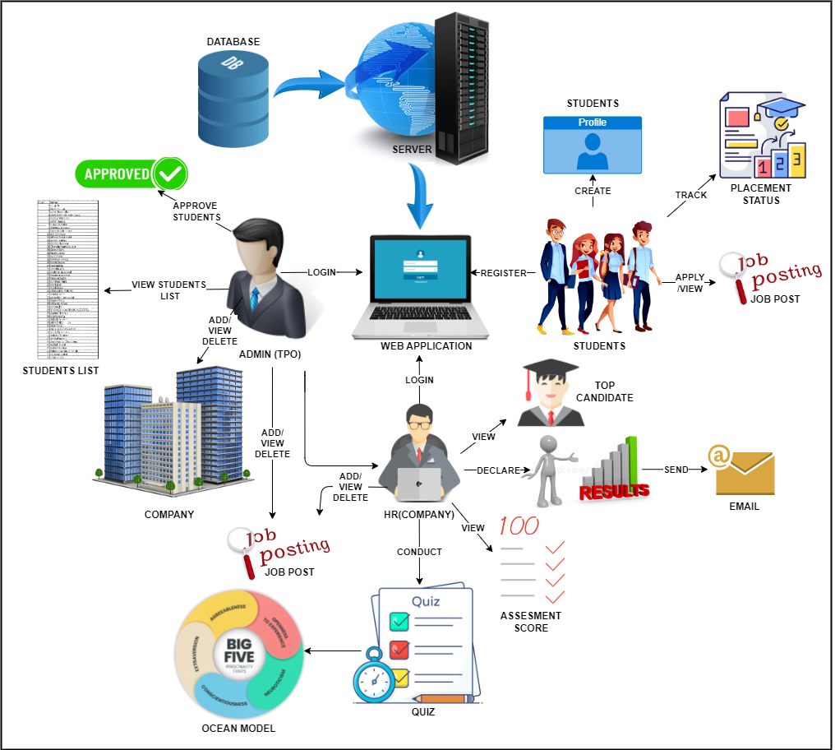

Fig.No. 4.1 System Architecture

1. **Data Flow Diagrams**

A Data Flow Diagram (DFD) is a graphical representation of how data flows within a system. It's commonly used in software engineering and business analysis to model processes and data flow within an organization or a specific system. In the context of a Training and Placement System, the DFD diagram can illustrate how data moves within the system to manage the training and placement processes.

1. **DFD (Level-0)**

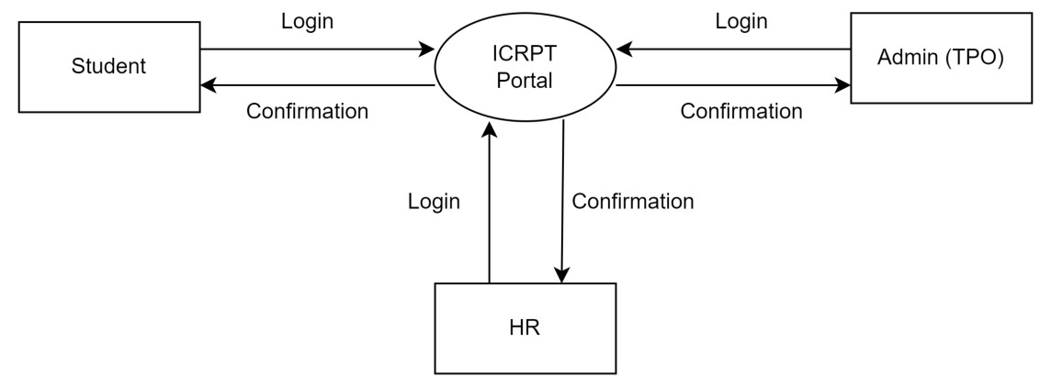DFD-0 displays a simplified high-level process diagram showing the login interactions between students, an admin (TPO), an HR to the ICRPT system

Fig.4.3.1 DFD Level 0

1. **DFD (Level-1)**

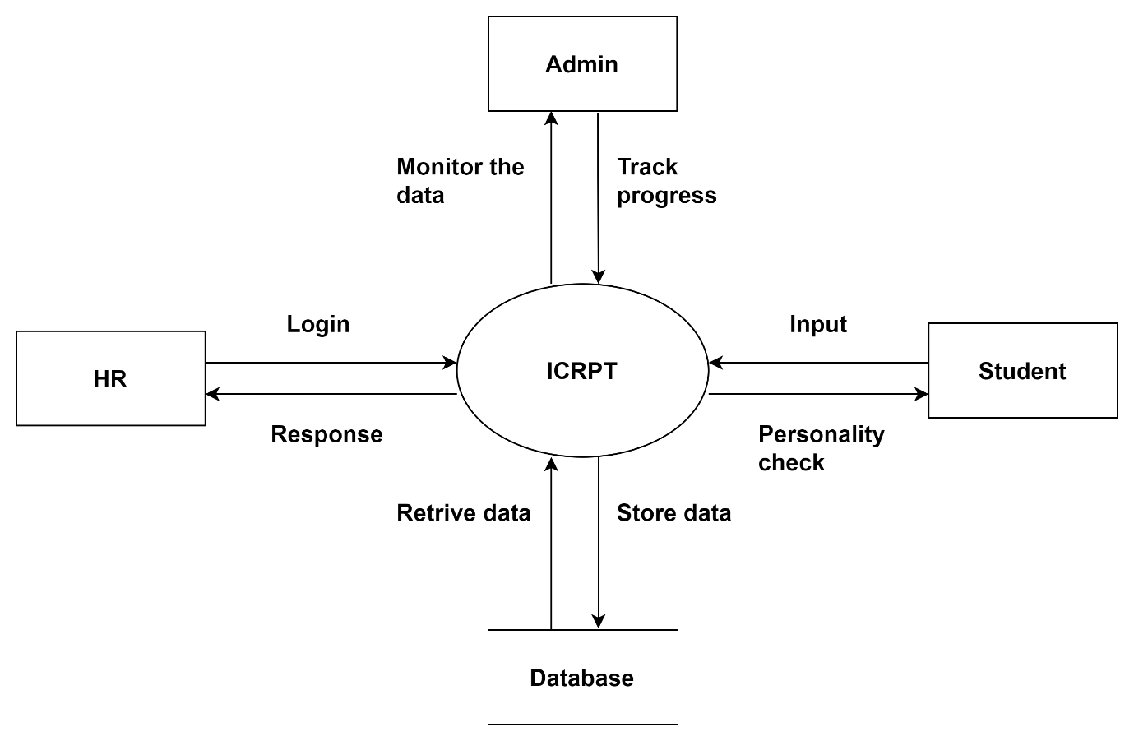

Fig.4.3.2 DFD Level 1

**Students:** Log in to ICRPT Portal, perform actions, receive confirmation.

**Admin (TPO):** Log in, perform administrative tasks related to training and placement, receive confirmation for actions within the portal.

**HR:** Receives login confirmation, indicating access to student or administrative information, indirectly interacts with the portal through the Admin (TPO).

ICRPT Portal serves as a central hub for student, Admin (TPO), and HR interactions, facilitating communication and processes with confirmation feedback.

1. **DFD (Level-2) –**

* **Student Module:**

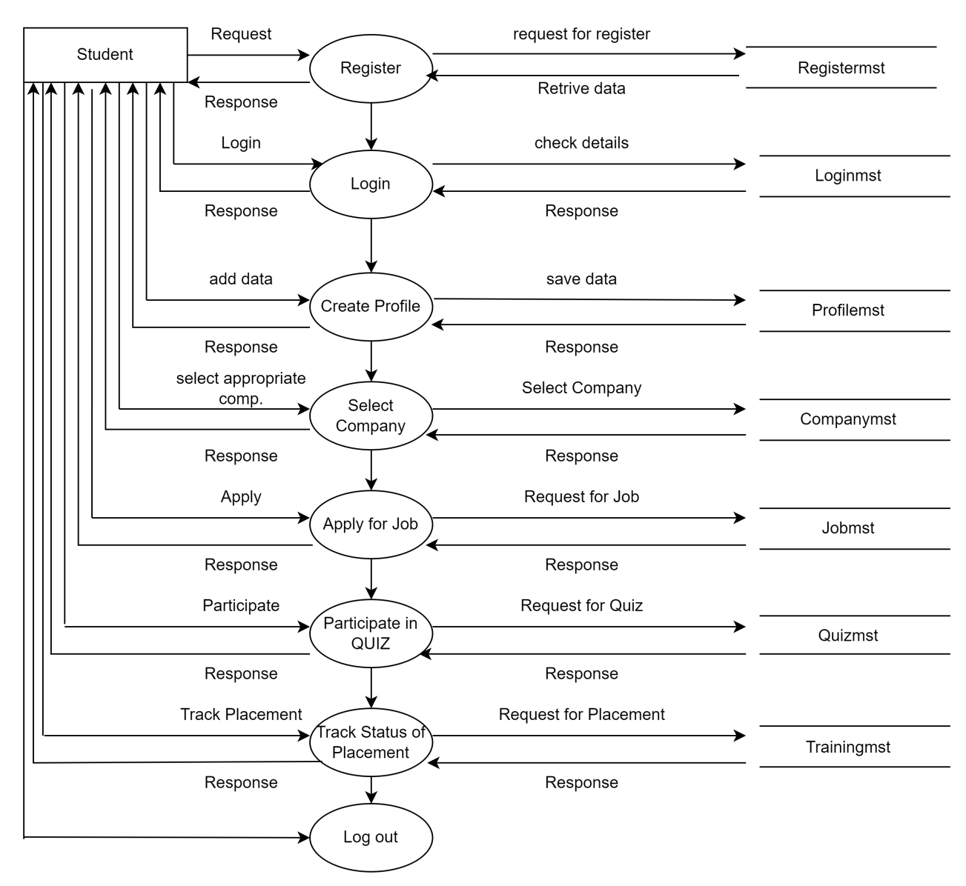**Register:** Student requests registration, provides details, system saves data.

Fig.4.3.3 DFD Level 2 Student

**Login:** Student provides credentials, system verifies against Loginmst table.

**Create Profile:** Student adds data, system creates profile in Profilemst table, confirms.

**Select Company:** Student requests company list, system retrieves from Companymst, student selects.

**Apply for Job:** Student requests to apply, system retrieves job details from Jobmst, student submits application, system saves data.

**Participate in Quiz:** Student requests to take quiz, system retrieves quiz details from Quizmst, student takes quiz, system records results.

**Track Placement:** Student requests application status, system provides information.

**Logout:** Student logs out of the system.

* **Admin (TPO) Module:**

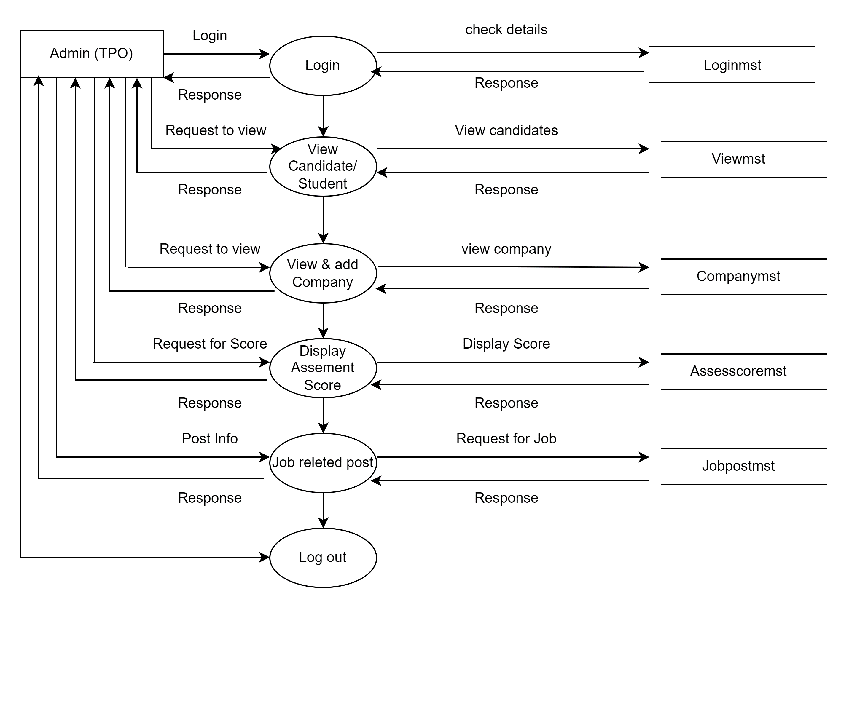 Fig.4.3.4 DFD Level 3 Admin (TPO)

**Login:** Admin logs in, system verifies credentials and access levels.

**View Candidates:** Employee requests candidate details, system displays from 'Viewmst' table.

**View & Add Companies:** System shows list of companies, allows addition to 'Companymst'.

**Display Score:** System shows assessment score from 'Assesscoremst' table.

**Job Post:** Recruiter fills job opening details, system saves in 'Jobpostmst'.

**Logout:** Admin logs out of the system.

* **HR Module:**

**Login:** HR logs in, system verifies credentials; on correct input, grants access, otherwise prompts for re-entry.

**Hire Candidate:** HR selects/approves candidates based on skills.

**Conduct Quiz:** HR constructs and conducts quizzes for candidate evaluation.

**Check Vacancy:** HR checks available vacancies, linked to 'Vacancymst' database.

**Assessment:** HR adds assessment data (e.g., personality, aptitude), system saves.

**Display Score:** System generates and displays scores to HR.

**Logout:** HR logs out of the system.

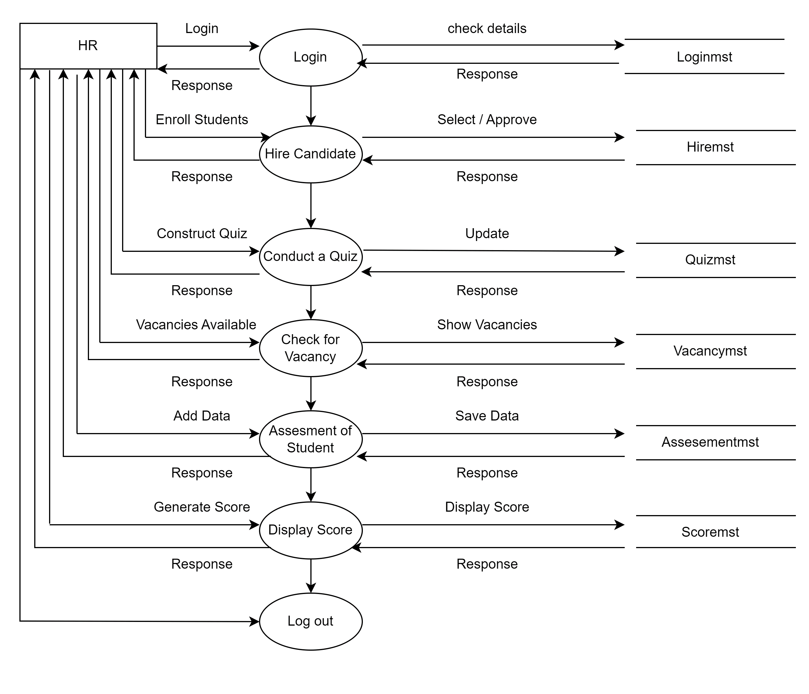

**Fig.4.3.5 DFD Level 4 HR**

1. **UML Diagram (Use Case)**

UML stands for Unified Modelling Language is a general purpose, developmental, modelling language in the field of software engineering. That is intended to provide a standard to visualize the design of the system. The accepted standard used when modelling assisting is known as a UML. A generic set of notations that are used when creating Unified Modelling Language diagrams. The Unified Modelling Language includes a set of graphic notation technique to create visual models of object-oriented software’s.

* + 1. **Use Case Diagram:**

A use case diagram is a visual representation of the interactions and relationships between different actors and the system or application they use. In this case, we are creating a use case diagram for a student module that encompasses various functionalities such as registration, login, creating a profile, selecting a company, applying for a job, participating in a quiz, tracking placement status, receiving notifications, and logging out.

* **Student Module:**

Register: Student provides personal info to create an account.

Login: Student enters credentials to access the system.

Create Profile: Student adds educational and skill details.

Select Company: Student browses and selects companies.

Apply for Job: Student applies for job positions.

Participate in Quiz: Student takes quizzes as required.

Track Placement Status: Student checks application progress.

Receive Notification: System sends updates.

Logout: Student ends the session.

* **Admin Module:**

Register: Admin signs up with personal details.

Login: Admin accesses the system with credentials.

View Candidate: Admin checks candidate profiles.

View and Add Companies: Admin manages company info.

Display Assessment Score: Admin views candidate scores.

Job-related Post: Admin posts job openings.

Logout: Admin ends the session.

* **HR Module:**

Register: HR signs up with personal details.

Login: HR accesses the system with credentials.

Hiring Students: HR reviews, interviews, and hires students.

Create Quiz: HR designs quizzes for evaluation.

Manage Quiz: HR updates quiz content.

Manage Vacancies: HR posts, updates, and closes job vacancies.

Candidates Evaluation: HR evaluates candidate applications.

Release Score: HR publishes assessment results.

Logout: HR ends the session.

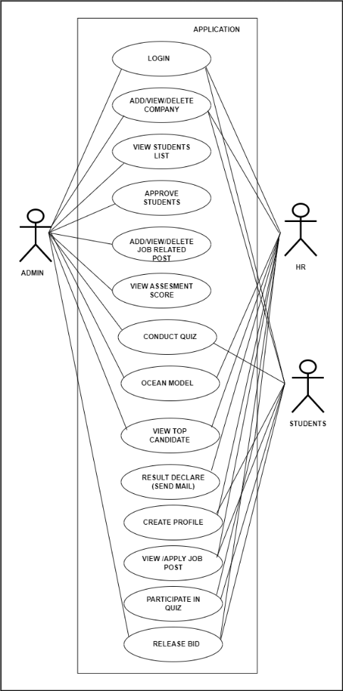

Fig. 4.4.1 System Usecase

1. **Activity Diagram**

The Integrated Campus Recruitment, Placement, and Training Analysis (ICRPT) system comprises three modules: Student, HR, and Teacher. The Student Module allows students to log in securely, manage their profiles, communicate with HR professionals, and track job applications. The HR Module is for HR professionals, enabling them to post job vacancies, review applications, and send offer letters after secure login. The Teacher Module, designed for training and placement officers, facilitates job matching and analytics. All modules include validation processes, and valid logins grant access to respective functionalities, while invalid logins trigger error messages, with each module serving a specific role in campus recruitment and placement.

1. **Student Module**

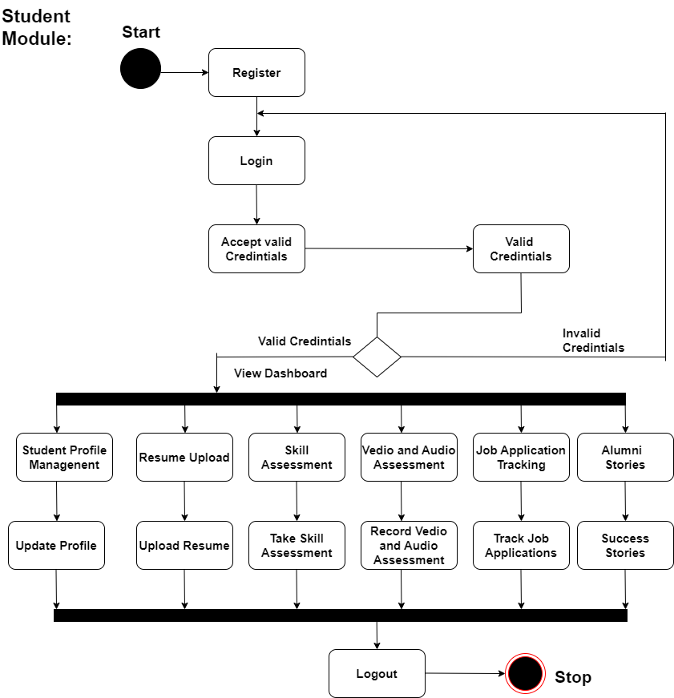

**Fig.4.5.1 Activity- Student**

Functionality: After secure login, students manage profiles, upload resumes, communicate with HR, and participate in assessments.

Valid Login: Access profile management, communication, and skill assessment.

Invalid Login: Displays error message.

Purpose: Empowers students to engage with job opportunities, showcase skills, and track applications efficiently.

1. **HR Module**

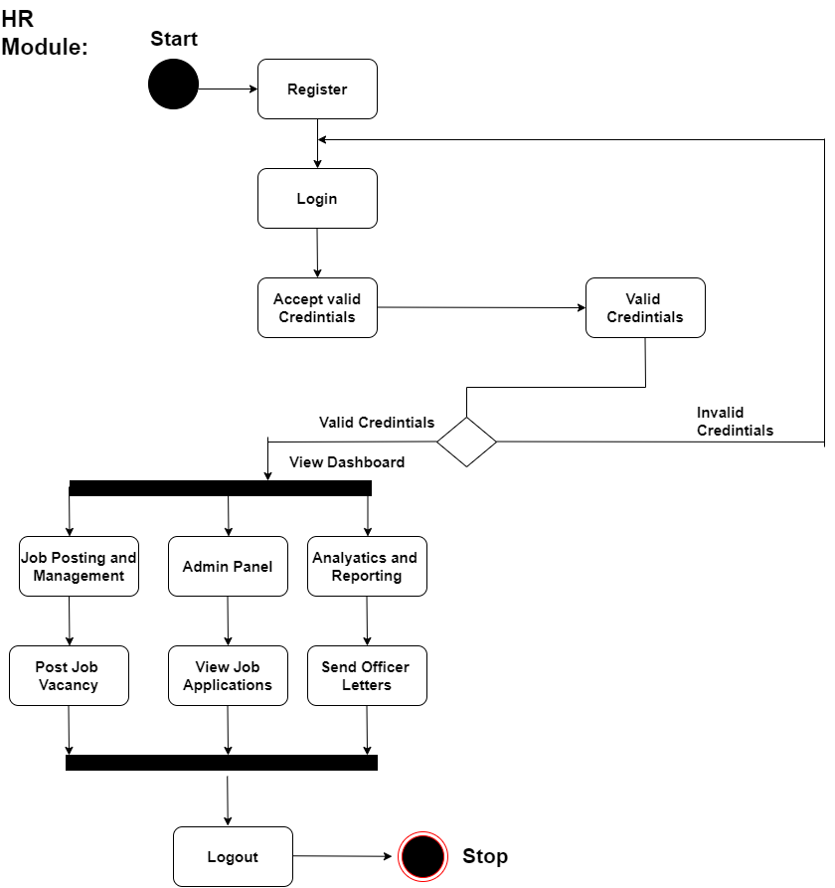

Fig.4.5.2 Activity- HR

Functionality: HR professionals post job vacancies, view applications, and send offer letters.

Valid Login: Access job posting, management, admin panel, analytics.

Invalid Login: Displays error message.

Purpose: Manages job postings and interactions with candidates effectively.

1. **TPO Module:**

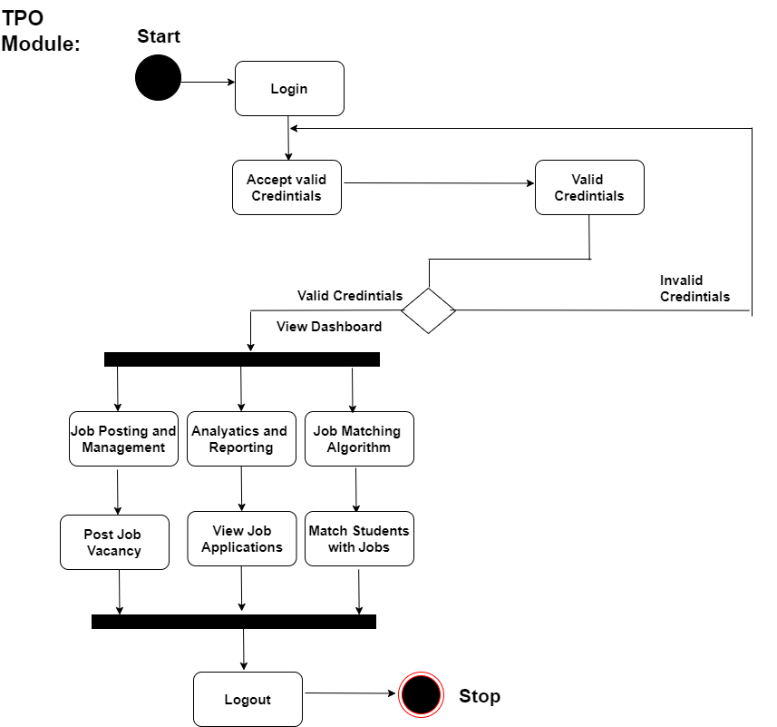

Fig.4.5.3 Activity- Admin(TPO)

Functionality: TPOs post vacancies, match students with jobs, review analytics.

Valid Login: Access job posting, management, analytics.

Invalid Login: Displays error message.

Purpose: Connects students with job openings, analyzes recruitment processes.

1. **Class Diagram**

Class Diagram is a static structure diagram that describes the structure of a system by showing the system classes, their attributes, operations and relationships.

This system appears to be a comprehensive platform for managing various aspects of campus recruitment, including student and employer interactions, job postings, assessments, and administrative functions.

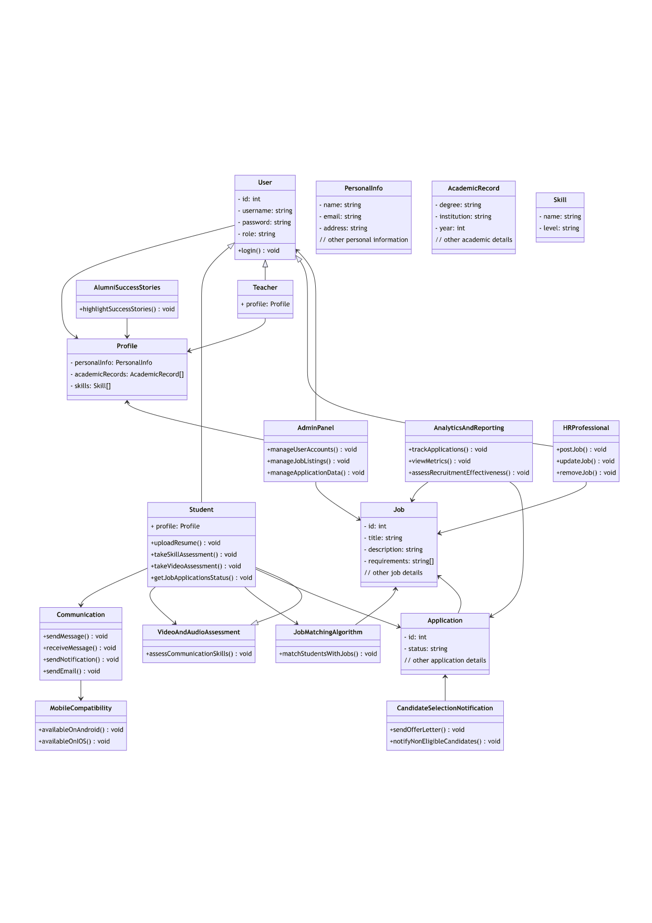

Fig.4.6 Class Diagram

1. **State Chart Diagram**

The state diagram shows the states of an object and represents activities as arrows connecting the states. The Activity Diagram highlights the activities. Each activity is represented by a rounded rectangle-narrower and more oval-shaped than the state icon. An arrow represents the transition from the one activity to the next. The activity diagram has a starting point represented by filled-in circle, and an end point represented by bulls eye.

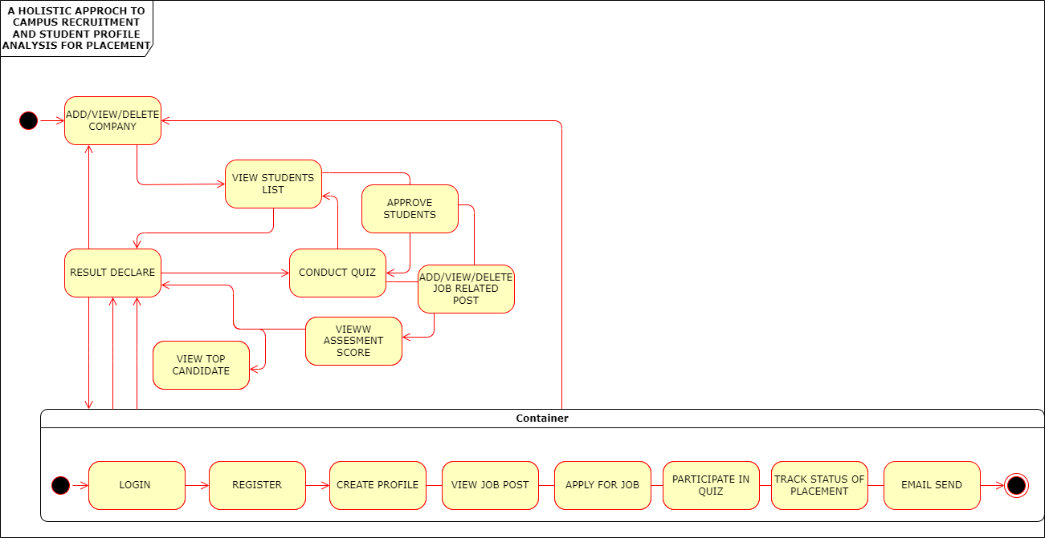

Fig.4.7 State Chart Diagram

1. **Deployment Diagram**

The deployment diagram shows how the ICRPT system's components work together to provide a comprehensive solution for integrated campus recruitment, placement, and training analysis. It starts with users accessing the system through client devices, progresses through load balancing, web servers, and data processing on the application server. The system interacts with database servers, cloud services, and various other components to deliver a secure, reliable, and data-driven platform for both Students and Employers. The email server, security infrastructure, and integration with university systems add layers of functionality to meet the needs of all system stakeholders.

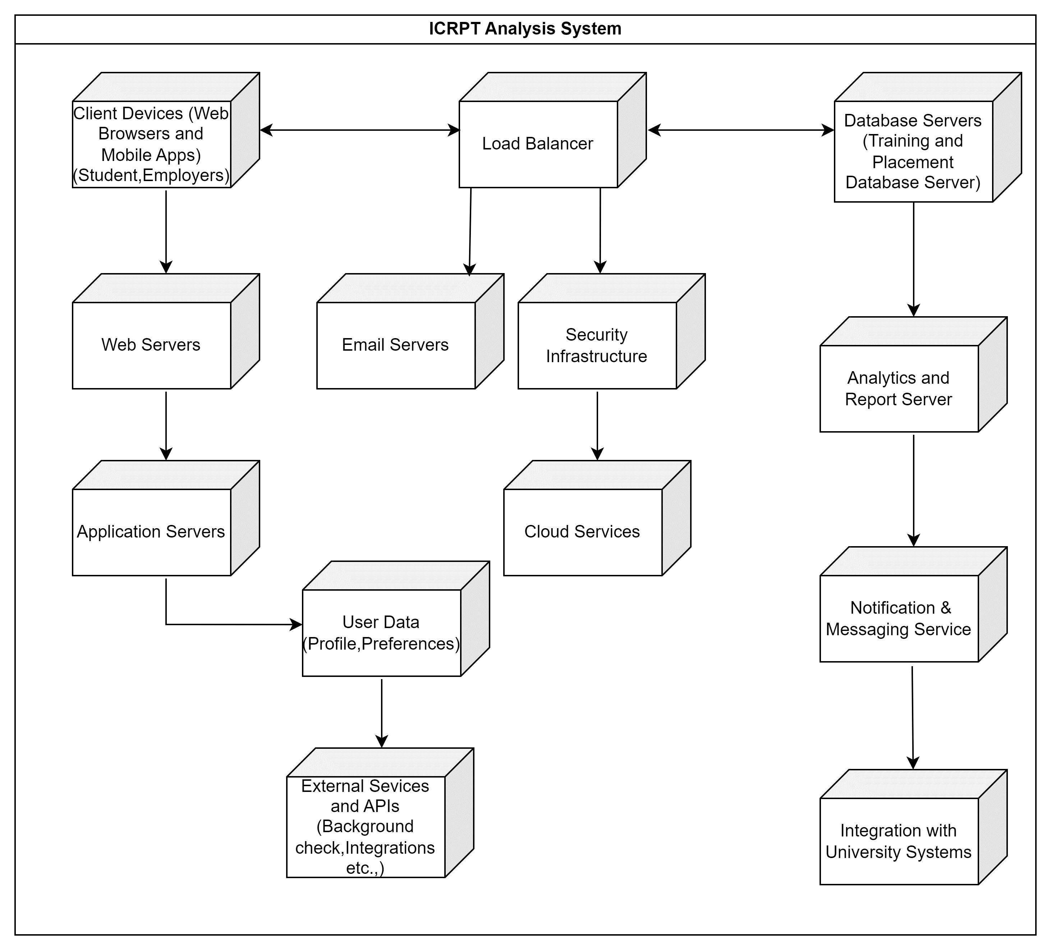

Fig.4.8 Deployment of ICRPT

1. **Sequence Diagram**

A Sequence Diagramis an interaction diagram that emphasis the time ordering of messages; a collaboration diagram is an interaction diagram that emphasizes the structural organization ofthe objects that send and receive messages. Sequence diagrams and collaboration diagrams are isomorphic, meaning that you can take one and transform it into the other.Sequence diagram and collaboration diagram are called INTERACTION DIAGRAMS. An interaction diagram shows an interaction, consisting of set of objects and their relationship including the messages that may be dispatched among them.A sequence diagram is an introduction that empathizes the time ordering of messages. Graphically a sequence diagram is a table that shows objects arranged along the X-axis and messages ordered in increasing time along the Y-axis.

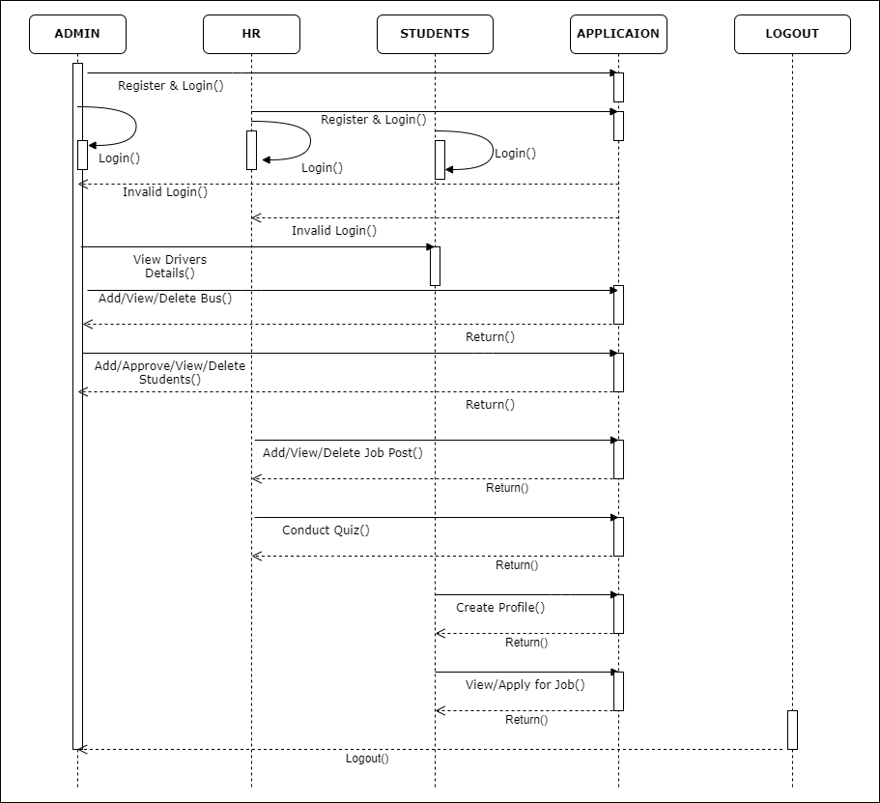

1. **Module Analysis**
2. **Modules**

* **Admin(TPO):**

1. Login
2. Add/View/Delete Company
3. View Student List
4. Approve Students
5. Add/View/Delete job related post
6. View Assessment Score

* **HR(Company):**

1. Login
2. Add /View/Delete Job Post
3. Conduct Quiz(The Big-5 Personality Traits)
4. View Assessment Score
5. View Top Candidate
6. Result declare(Email send)

* **Students:**

1. Register
2. Login(After Approval)
3. Create Profile
4. View Job Post
5. Apply for job
6. Participate in Quiz
7. Track Status of Placement
8. **Purpose of Module**

* **Admin (TPO):**

1. Login: Training and Placement Officers (TPOs) access the system securely through a login interface, ensuring only authorized personnel can manage recruitment activities.
2. Company Management: TPOs have the authority to add, view, and delete company profiles within the system. They can update company information, including contact details and recruitment preferences, ensuring accurate representation for students.
3. Student List: TPOs can access and review the comprehensive list of registered students. This feature allows TPOs to track student participation, identify trends, and ensure all eligible students are considered for job opportunities.
4. Student Approval: TPOs have the responsibility to approve registered students, granting them access to the recruitment system. This step ensures that only verified students can interact with job postings and assessments.
5. Job Post Management: TPOs are responsible for managing job postings within the system. They can add new job opportunities, review existing postings, and remove outdated listings as needed. This feature enables TPOs to keep the job board updated with relevant and current opportunities.
6. Assessment Monitoring: TPOs monitor and evaluate student assessment scores to track performance. They can view individual assessment results, analyze trends across student cohorts, and identify areas for improvement. This data-driven approach helps TPOs provide targeted support and guidance to students throughout the recruitment process.

* **HR (Company):**

1. Login: HR personnel representing companies access the system securely through a login interface, ensuring authorized access to recruitment functionalities.
2. Job Posting: HR personnel add, view, or delete job postings within the system. They can create detailed job descriptions, specify job requirements, and set application deadlines to attract potential candidates.
3. Personality Assessment: HR personnel can administer personality quizzes, such as the OCEAN model, to assess candidate suitability. These quizzes help HR personnel understand candidates' personality traits, communication styles, and work preferences, informing their hiring decisions.
4. Assessment Review: HR personnel review candidate assessment scores to evaluate suitability for job roles. They can access individual assessment results, compare scores against job requirements, and make informed decisions about candidate selection.
5. Candidate Selection: HR personnel identify top-performing candidates based on assessment results. They can use assessment data to shortlist candidates, schedule interviews, and ultimately select the most suitable candidates for job roles.
6. Result Communication: After the recruitment process is complete, HR personnel communicate recruitment outcomes to candidates via email. They notify candidates about the status of their applications, provide feedback on assessment results, and extend job offers to successful candidates. This transparent and timely communication helps maintain positive relationships with candidates and ensures a smooth recruitment experience.

* **Students :**

1. Registration: Students sign up for access to the recruitment system by providing personal information and academic details. This step allows students to create profiles and participate in the recruitment process.
2. Login: Upon approval, students securely access the system through a login interface, gaining access to job postings, assessments, and other recruitment functionalities.
3. Profile Creation: Students create comprehensive profiles within the system, showcasing their academic achievements, skills, work experience, and career interests. A well-crafted profile increases visibility to potential employers and improves chances of being considered for job opportunities.
4. Job Exploration: Students explore available job opportunities posted by companies within the system. They can review job descriptions, requirements, and application deadlines to identify suitable positions.
5. Application Submission: Interested students submit applications for desired job roles through the system. They may include personalized cover letters, resumes, and other supporting documents to enhance their applications.
6. Quiz Participation: Students have the option to participate in optional quizzes, such as personality assessments based on the Big Five traits. These quizzes allow students to showcase their personality traits, communication skills, and problem-solving abilities to potential employers.
7. Placement Tracking: Throughout the recruitment process, students can monitor the progress of their job applications and placement status within the system. They receive updates on application statuses, interview invitations, and final job offers, enabling them to stay informed and engaged in the recruitment journey.
8. **Algorithm**

* **Student Module**

1. Start
2. If valid credentials are provided by student, proceed to Step 3; otherwise, repeat Step- 2.
3. Allow students to create, update, and delete their profiles.by securely storing data.
4. Participates in skill assessments in various formats.
5. Allow students to apply for jobs by completing skill assessments.
6. Notify students of relevant job opportunities based on their preferences.
7. Provide students with real-time updates/track on the progress/status of their job applications.
8. Enable easy access for students to view alumni success stories.
9. Stop

* **HR Module**

1. Start
2. If valid credentials are provided by HR , proceed to Step 3; otherwise, repeat Step-2.
3. Allow HR professionals to manage and store job vacancies.
4. Create, manage, and score quizzes for candidates as part of the assessment process.
5. Consider candidate profiles and job vacancy requirements to make suitable recommendations.
6. Create a hiring workflow for candidate selection, interviews, and offers.
7. Allow rating and feedback on candidate profiles evaluation and rating.
8. Set up secure communication for HR professionals.
9. Enable securely release assessment scores to candidates.
10. Notify candidates about their selection status, interviews, and offers.
11. Stop

* **Admin Module**

1. Start
2. If valid credentials are provided by Admin, proceed to Step 3; otherwise, repeat

Step- 2.

1. Allow administrators to add, update, or remove student profiles and job listings.
2. Allow administrators to add, edit, or remove alumni success stories.
3. Integrate reporting and analytics for data-driven decisions such as user activity, job statistics, and success stories.
4. Stop
5. **Flowcharts**

Flowcharts are nothing but the graphical representation of the data or the algorithm for a better understanding of the code visually. It displays stepby-step solutions to a problem, algorithm, or process. It is a pictorial way of representing steps that are preferred by most beginner-level programmers to understand algorithms of computer science, thus it contributes to troubleshooting the issues in the algorithm. A flowchart is a picture of boxes that indicates the process flow in a sequential manner. Since a flowchart is a pictorial representation of a process or algorithm, it’s easy to interpret and understand the process. To draw a flowchart, certain rules need to be followed which are followed by all professionals to draw a flowchart and is widely accepted all over the countries.

**Student Module:** Studentscan create and manage profiles, search for jobs, build resume, receive notifications, access skills.

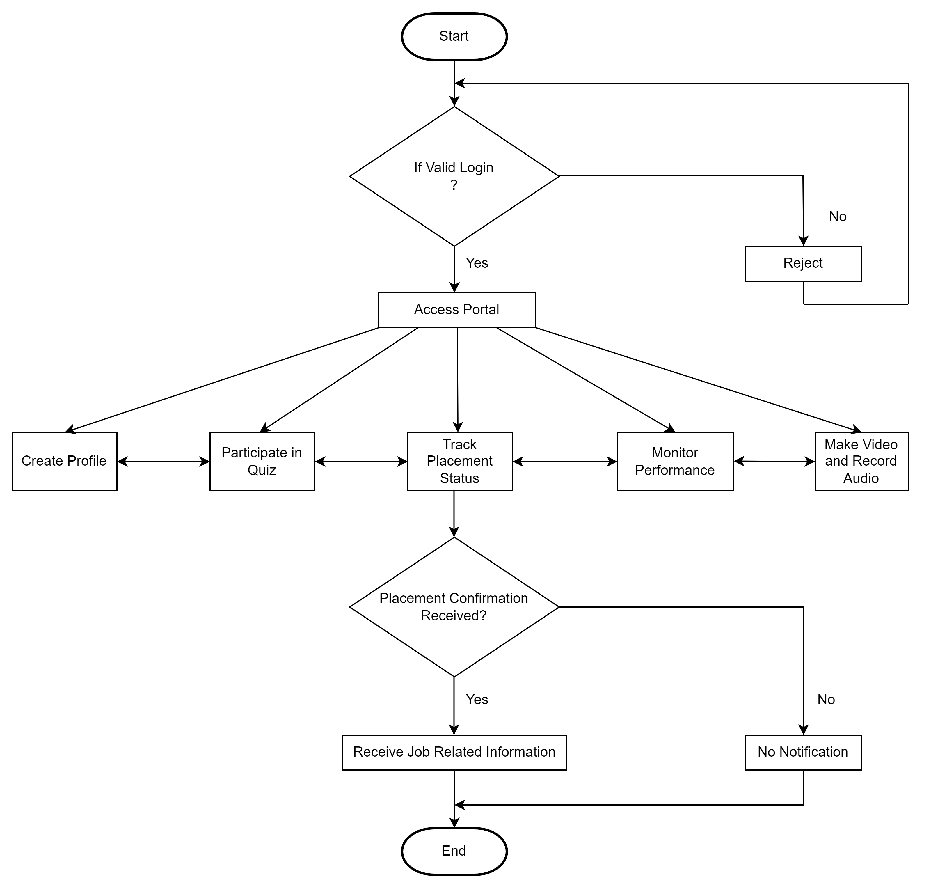

Fig.4.11.1 Flow Chart

**Admin Module:** Teachers can manage profiles, post job opportunities, provide recommendations and communicate with students.

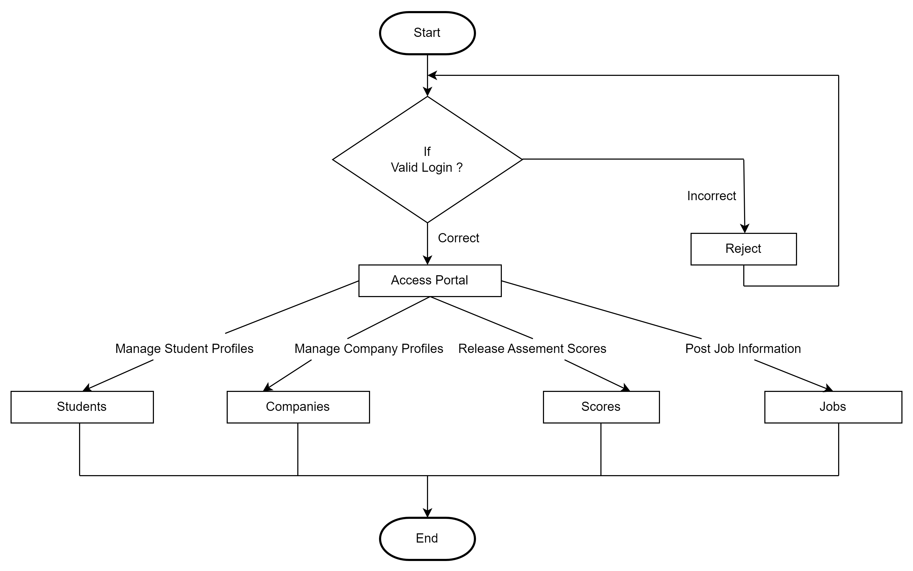

Fig.4.11.2 Flow Chart

**HR Module:** HR personnel can manage company profiles, post job listing, handle candidate application, access analytics and reports, communicate with students and teachers and provide feedback.

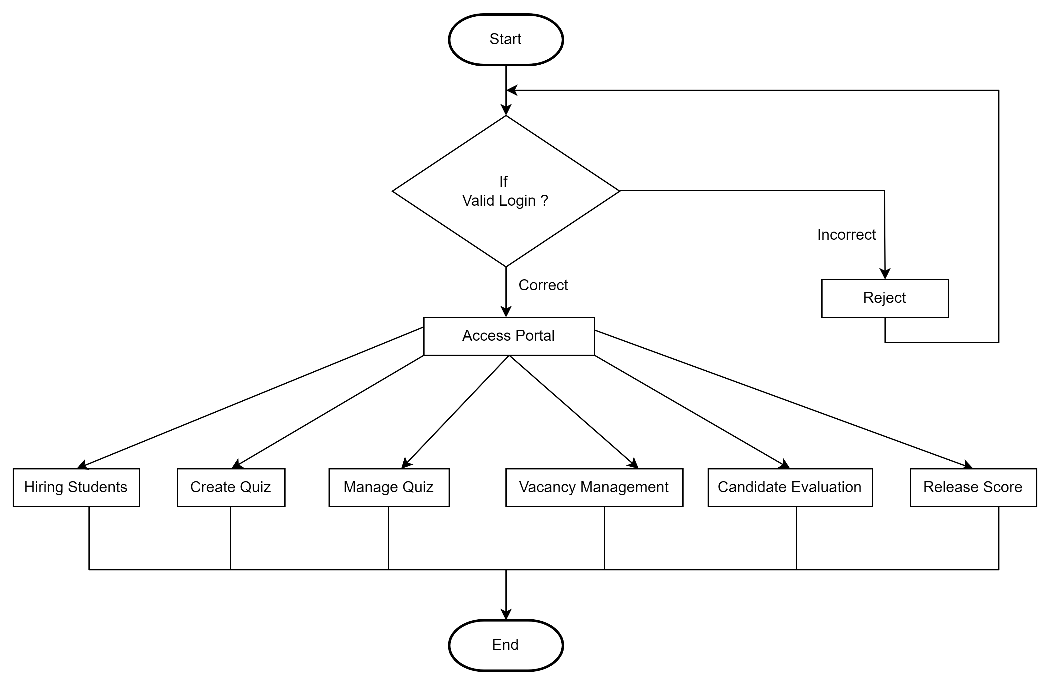

Fig.4.11.3 Flow Chart

The above flowchart depicts the system flow. Flowchart for ICRPT can help visualize the sequential steps and decision points in the application workflow. Uses start by logging into the application. After logging in, they reach the dashboard. Depending on their roles, they can access specific modules. User can logout when they are done using the application. This flowchart provide a high-level overview of the application workflow showing how different users roles interact with the various modules and functionalities. In a real-world scenario each of these modules would have its own detailed flowchart to outline the specific actions and interactions within that module

**CHAPTER – 5 : RESULTS AND SCREENSHOTS WITH EXPLAINATION**

1. **Home Page**

The ICRPT homepage features a streamlined navigation bar , offering quick access to essential actions including Login for Admin, Student, and Company (HR) modules, along with About Us details and Contact Us options and a convenient search bar functionality. With a focus on connecting students with job opportunities, the homepage provides a concise introduction to our platform's mission and features.

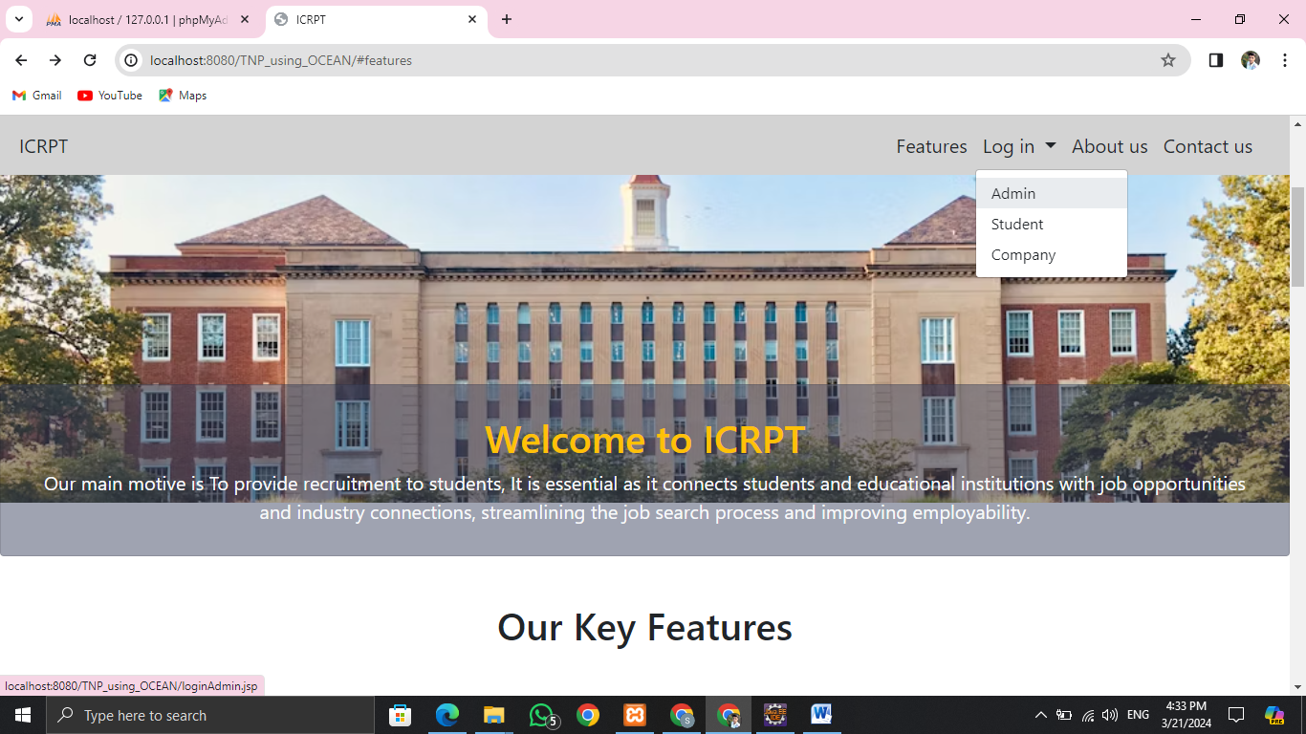

1. Home Page

1. **Login Page**

In ICRPT, the login feature serves as a gateway for various user roles, including Admin, Student, and Company (HR). Each user type is granted access to specific functionalities tailored to their needs

1. **Admin-**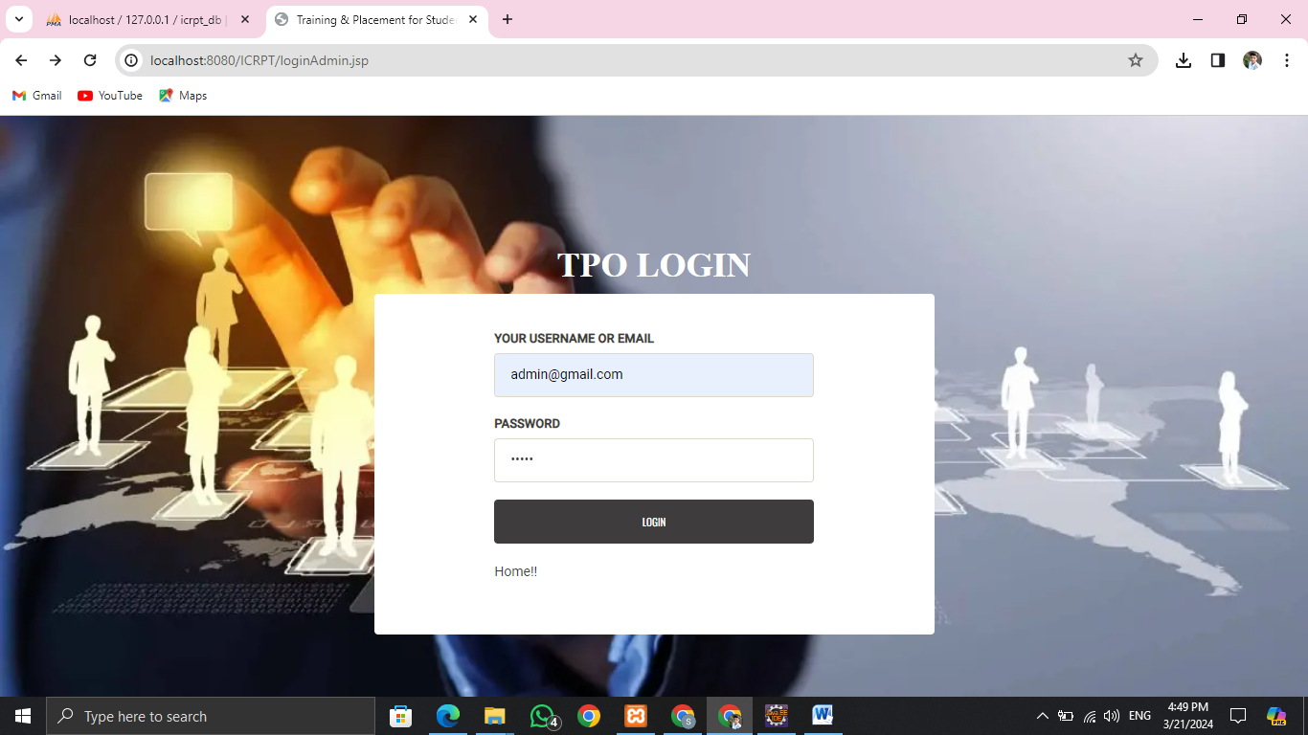

2.1. Admin Login Page

1. **Student-**

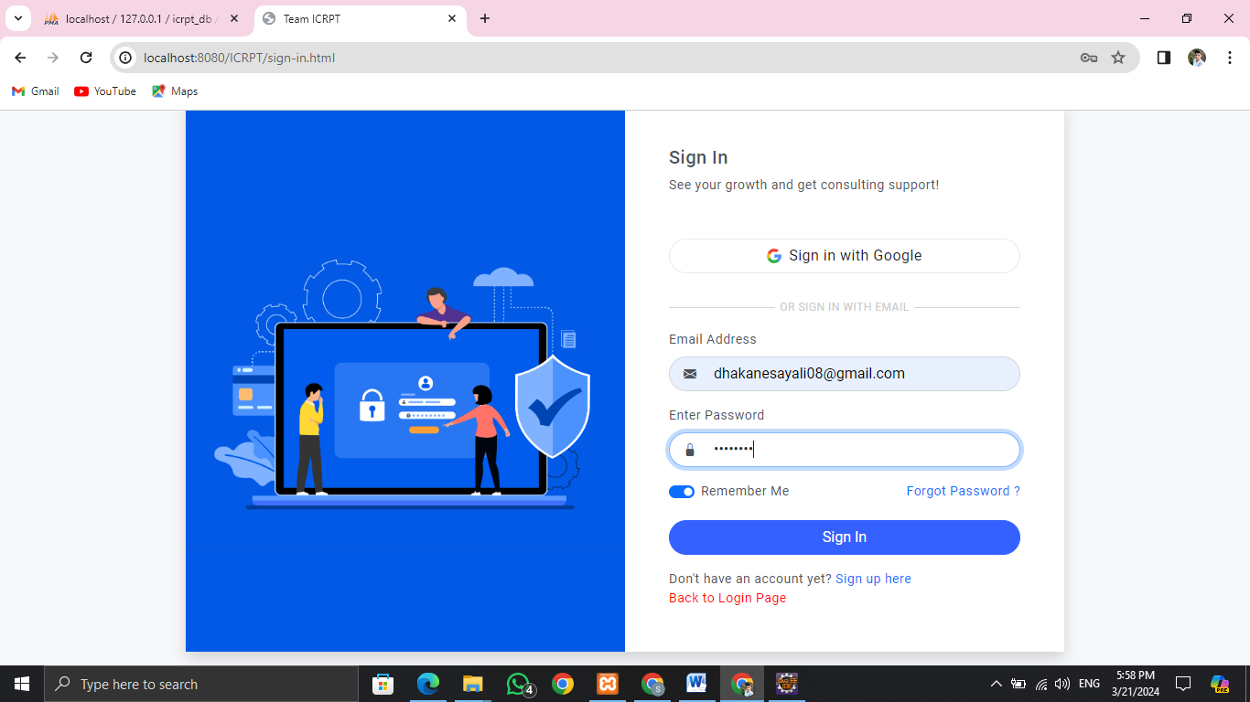

2.2. Student Login Page

1. **Company (HR)-**

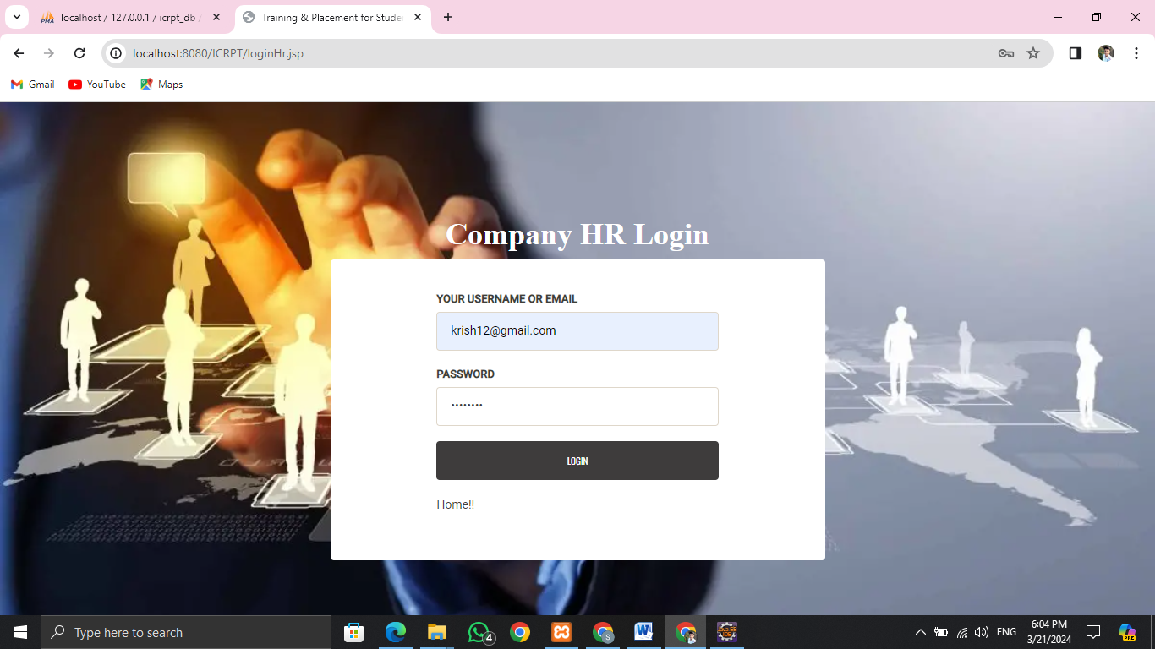

2.3. Company(HR) Login Page

1. **Dashboard**

The ICRPT dashboard simplifies recruitment processes, boosts efficiency, and offers a centralized platform tailored to individual user requirements, ensuring easy access to relavant information and functionalities.

1. **Admin-**

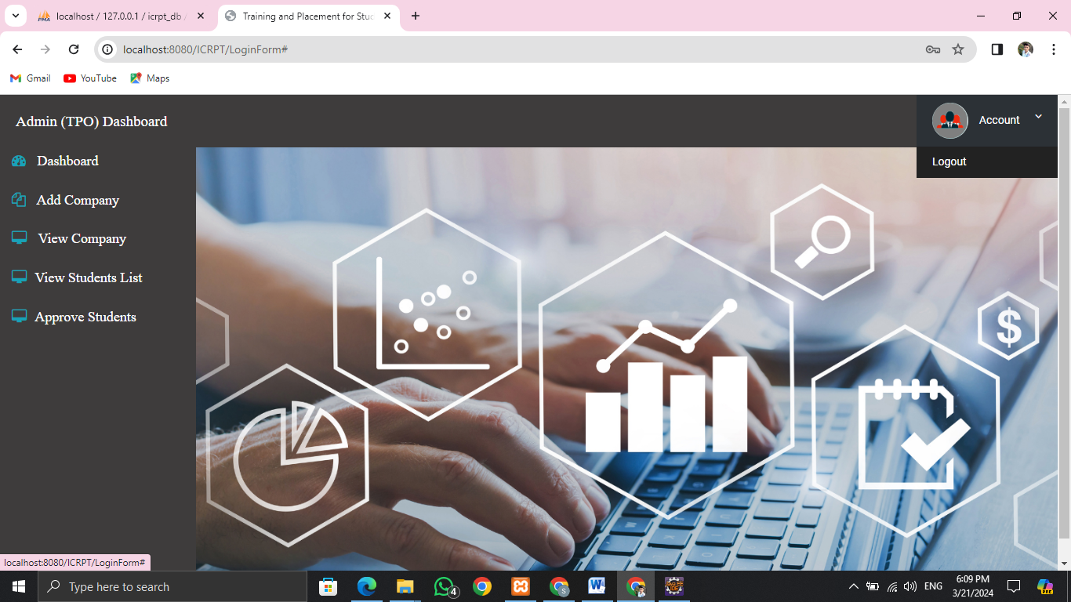

3.1. Admin Dashboard

1. **Student-**

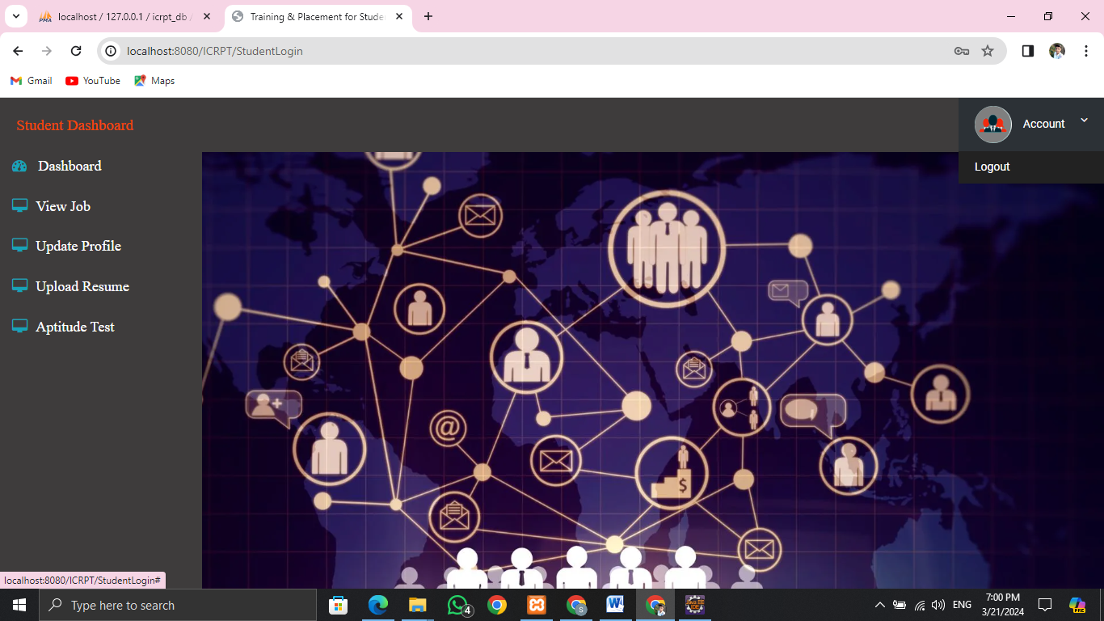

3.2. Student Dashboard

1. **Company (HR)-**

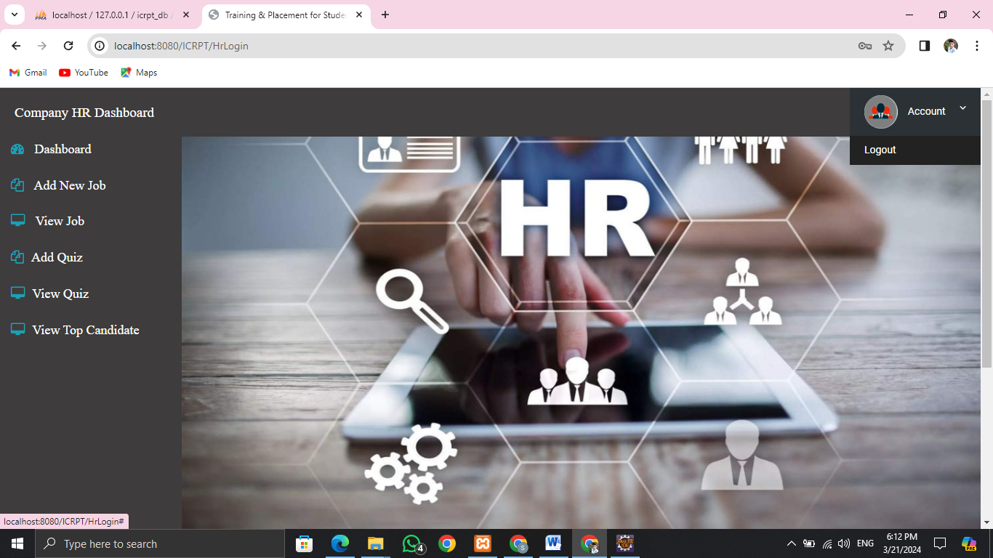

3.3. Company (HR) Dashboard

1. **Admin Functionalities-**
2. **Add Company-HR**

The "Add Company-HR" feature in ICRPT allows HR representatives or recruiters from companies to create accounts and profiles within the platform.

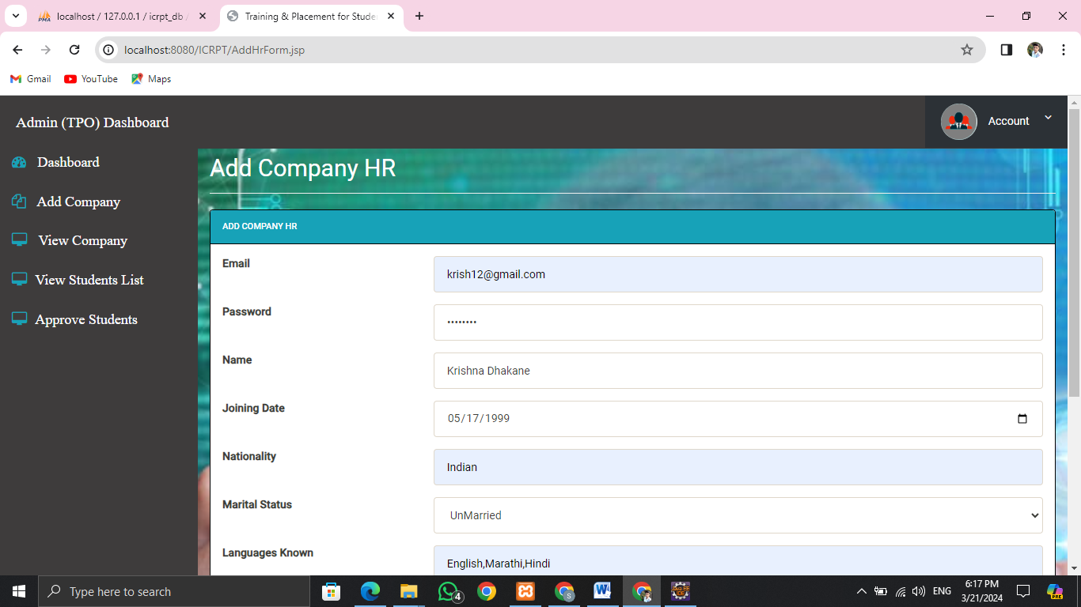

4.1 Add Company HR

1. **View Company-HR**

The "View COMPANY-HR" feature in the admin login section of ICRPT allows administrators to access and view information related to companies and their HR representatives registered on the platform.

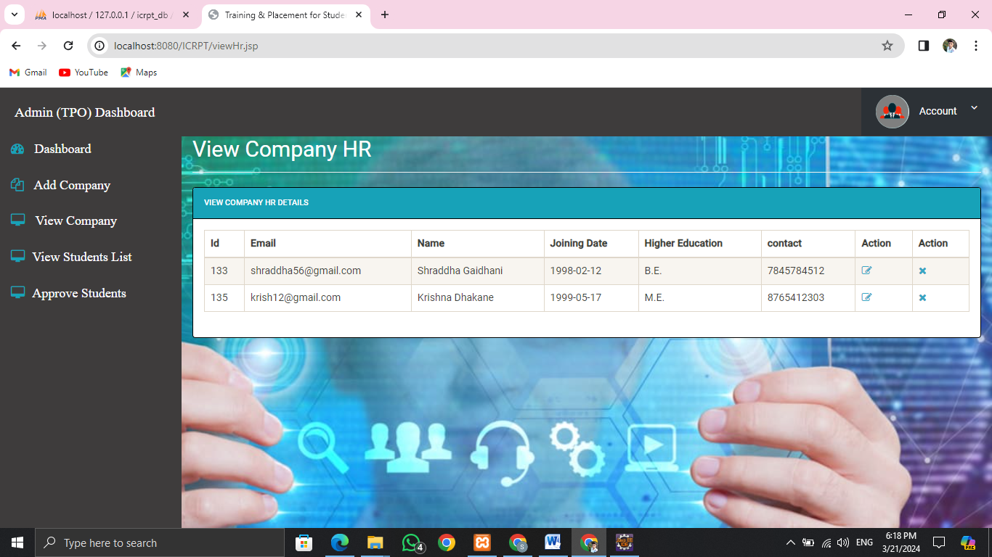

4.2 View Company HR

1. **View Student List**

The "View Student List" feature in ICRPT's admin login allows administrators to see a list of registered students with their key details.

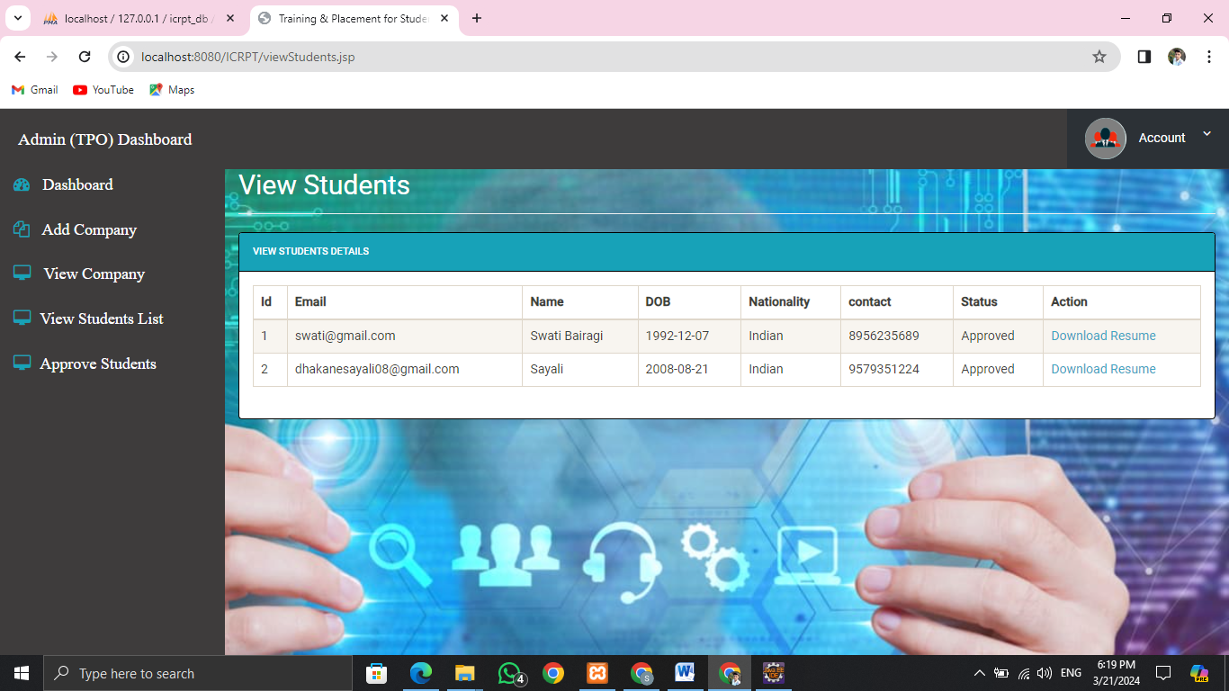

4.3 View Student List

1. **Approve Students**

The "Approve Students for login" feature in the Admin login of ICRPT allows administrators to review and authorize student accounts for access to the platform.

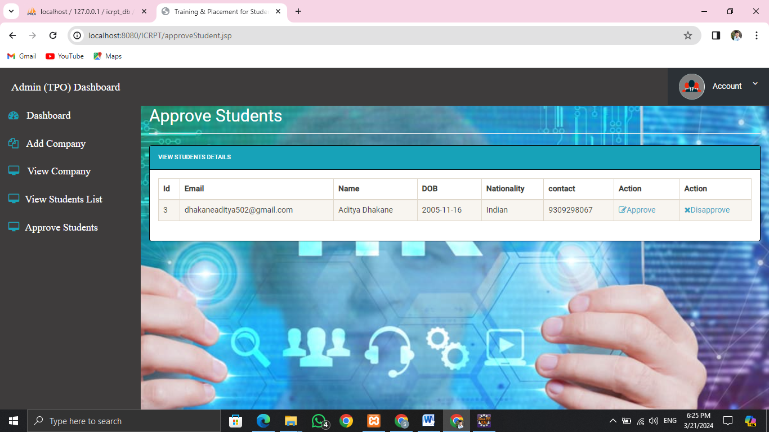

4.4 Approve Students

1. **Student Functionalities-**
2. **View Jobs and Apply**

The "View Jobs and Apply" feature in ICRPT allows users, particularly students, to browse available job opportunities and directly apply for positions of interest.

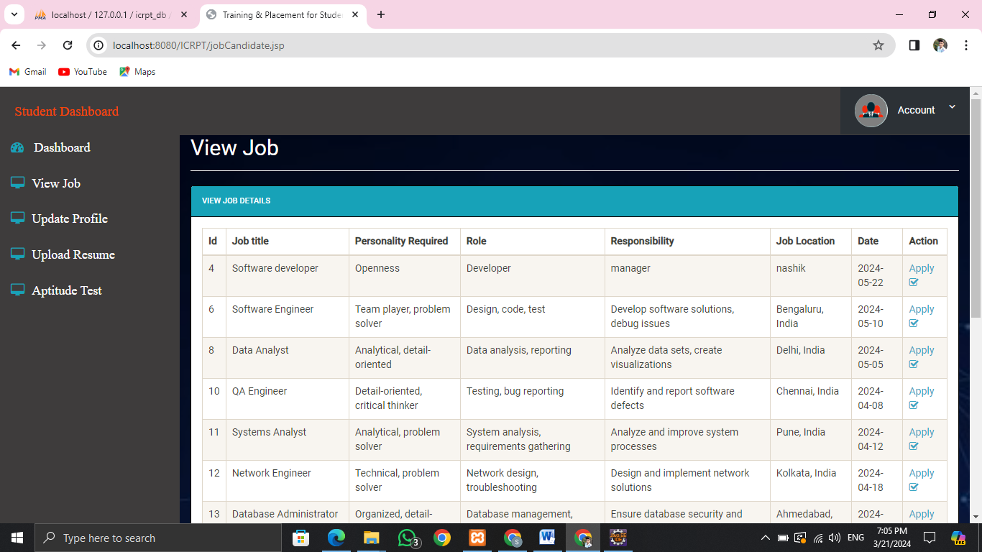

5.1 View Jobs and Apply

1. **Apply for Job- Quiz Competition**

The ICRPT enables students to participate in quiz competitions, helping them enhance their skills (Personality Factors) and potentially attract job offers from participating companies or educational institutions.

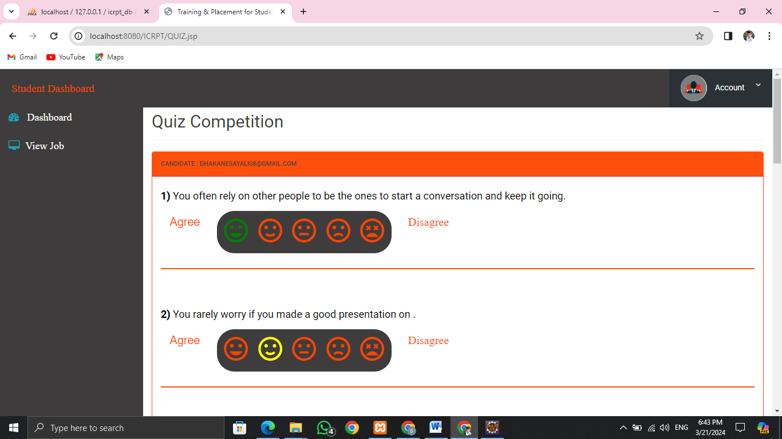

5.1.1 Apply for Job-Quiz Competition

1. **Update Profile**

The ICRPT allows users to modify their personal information stored within the platform.

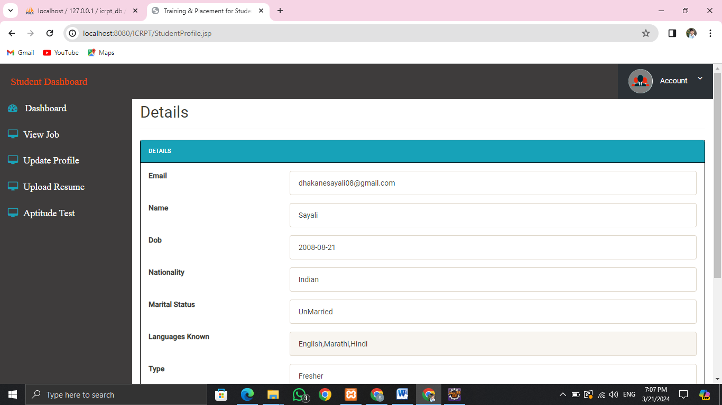

5.2 Update Profile

1. **Upload Resume**

The ICRPT allows users, particularly students, to submit their resumes directly through the platform.

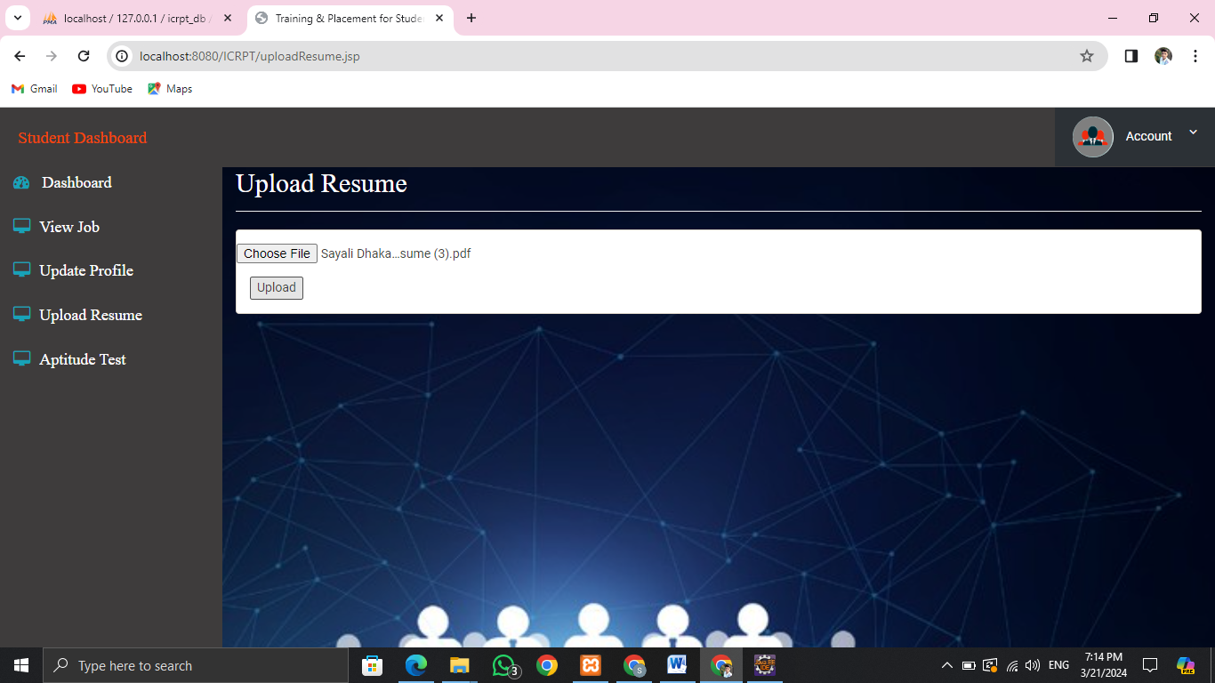

5.3 Update Resume

1. **Aptitude Test**

The "Aptitude Test for Student" feature in ICRPT allows students to showcase their skills and strengths to potential employers through tailored tests, enhancing their employability. Employers benefit by gaining insights into candidates' capabilities, facilitating better recruitment decisions.

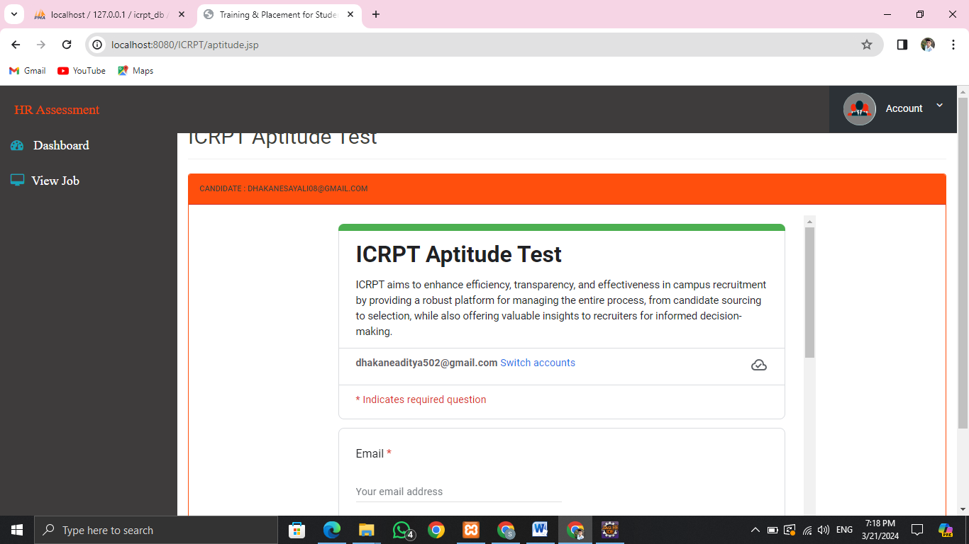

5.4 Aptitude Test

1. **Company-HR Functionalities-**
2. **Add new Job**

The "Add New Job" feature in the Company (HR) section of ICRPT allows HR representatives to post new job vacancies directly onto the platform. This feature streamlines the recruitment process by providing a centralized platform for job postings.

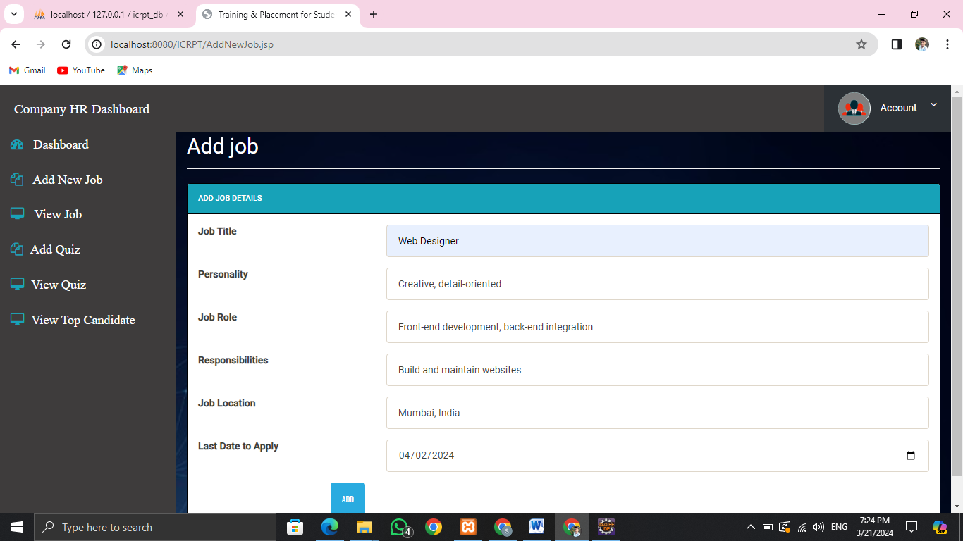

6.1 Add new Job

1. **View Job**

In ICRPT's Company (HR) section, the "View Job" feature allows HR personnel to access and review detailed job listings from educational institutions or organizations, streamlining the recruitment process.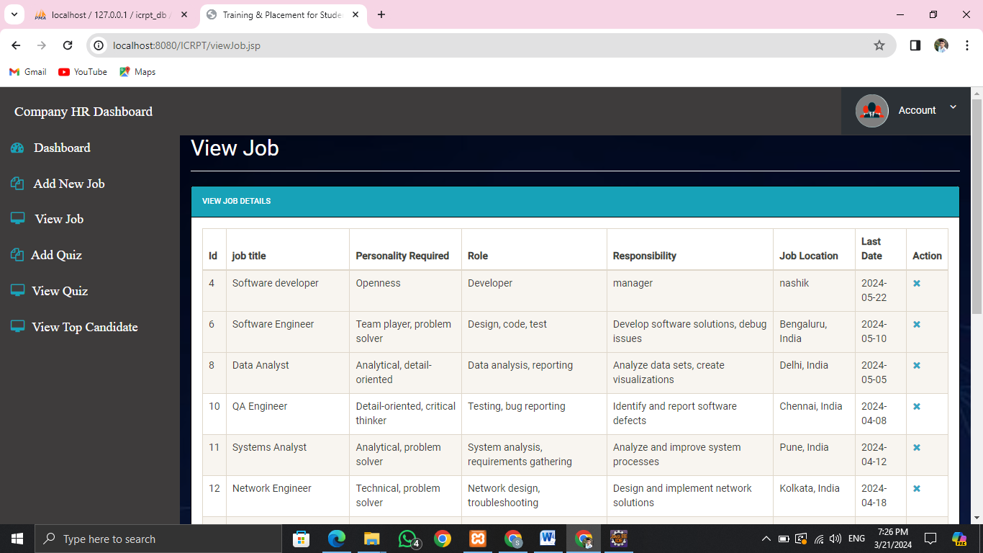

6.2 View Jobs

1. **Add Quiz**

The "Add Quiz for Personality Test in Company (HR) Section" feature in ICRPT allows HR departments within companies to create and administer personality quizzes for job applicants or current employees. This feature enables HR professionals to assess candidates' personalities, traits, and compatibility with company culture or specific job roles.

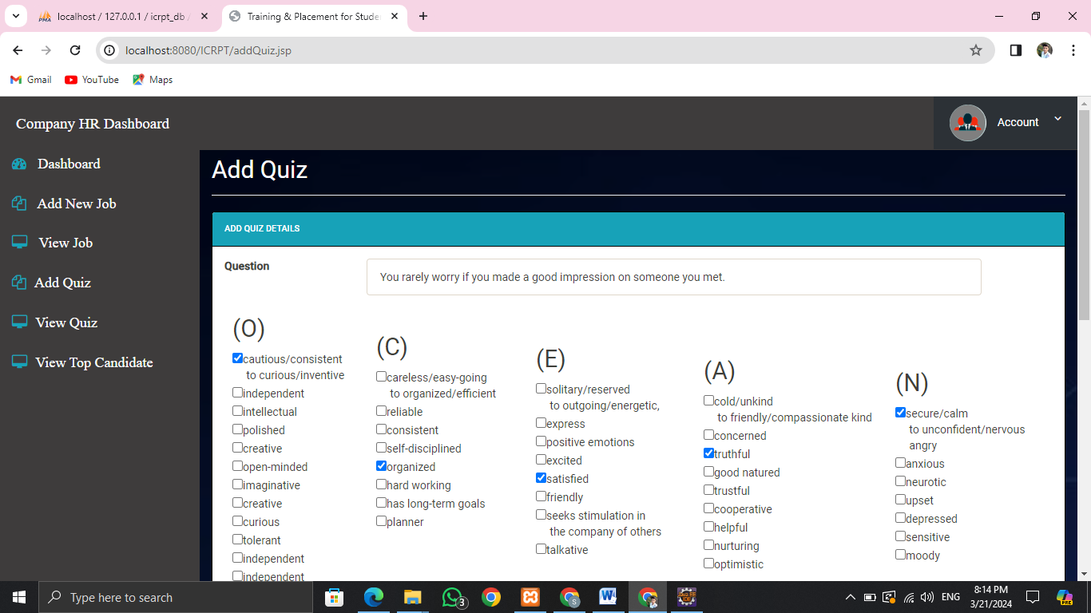

6.3 Add Quiz

1. **View Quiz**

The "View Quiz" feature in the Company (HR) section of ICRPT allows HR representatives or recruiters from companies to access quizzes or assessments that are part of the recruitment process.

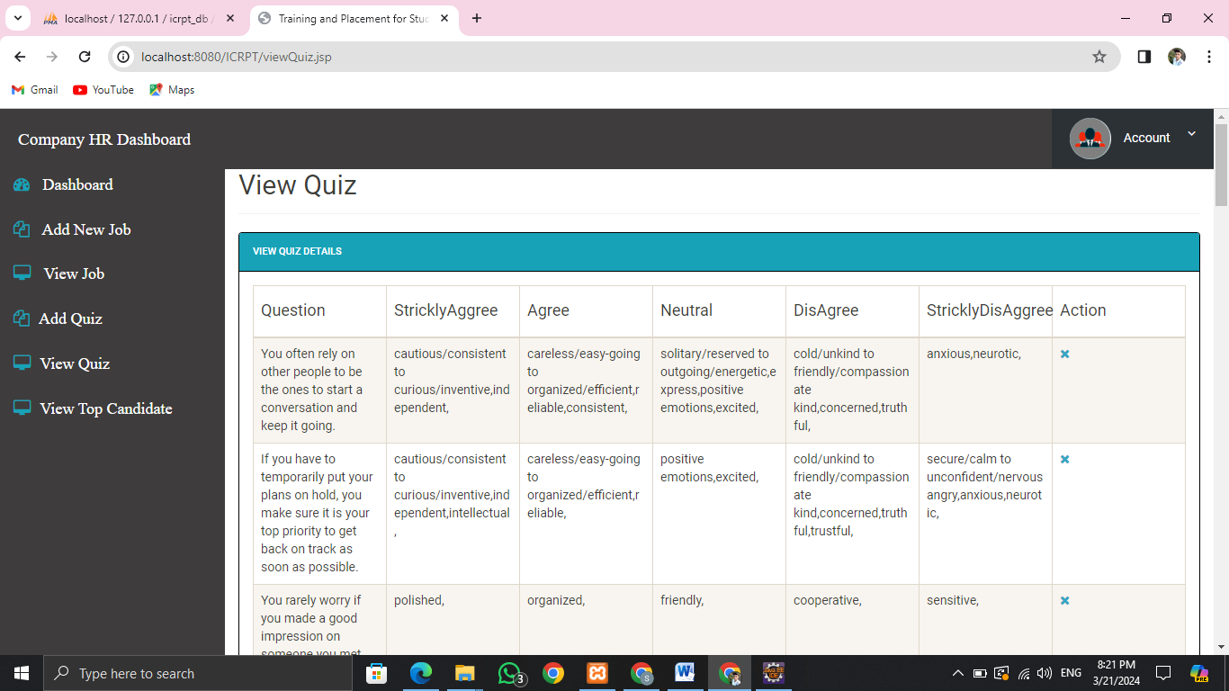

6.4 View Quiz

1. **View Top Candidates**

The ICRPT enables HR professionals to assess candidates' personality traits. By abilities,skills and personality traits also their count, HR can identify candidates who best fit the company culture and job requirements, streamlining the hiring process and ensuring better candidate selections.

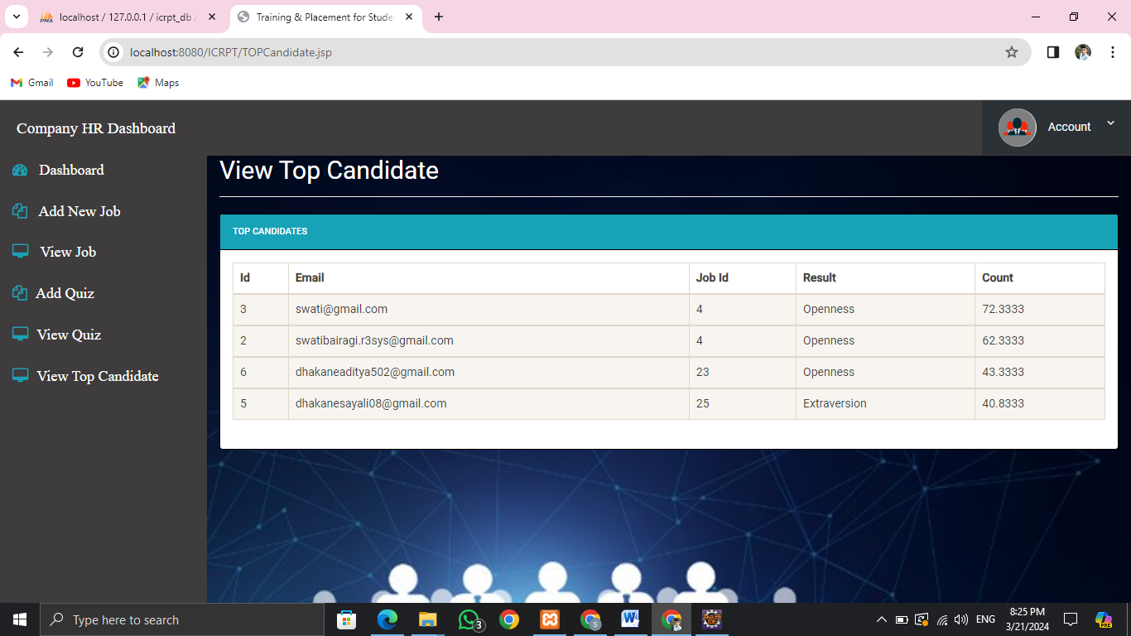

6.5 View Top Candidates

**CHAPTER – 6 : SOFTWARE TESTING**

**6.1 Introduction**

Software testing is the process of executing a program to find errors, ensuring it performs as intended and doesn't produce unintended results, aiming for predictability and consistency. It serves quality assurance, verification, validation, and reliability estimation purposes.

**6.2 Objectives of Software Testing**

The major objectives of software testing are as follows:

* + - 1. Finding defects which may get created by the programmer while developing the software.
      2. Gaining confidence and providing information about the level of quality.
      3. To prevent defects.
      4. To make sure that the end result meets the business and user requirements.
      5. Gain the confidence of the customers by providing them a quality product.
      6. To ensure that if satisfies the BRS that is Business Requirement Specification and SRS that is System Requirement Specification.

Conducted Black Box and White Box testing including Unit Testing and Stress Testing to assess software performance.

**6.3 Test Cases**

**6.3.1 Functional testing**

**Test Cases for Admin Login**

|  |  |  |  |  |  |  |
| --- | --- | --- | --- | --- | --- | --- |
| **Module Name:-** Admin Module    **Testing Type:-** Unit Testing   **Test Objective:-** To check GUI working of all the functionality   **Test Performed By:-** Aditya Dhakane | | | | | | |
| **Test Case ID** | **Test Description** | **Input Data** | **Expected Result** | **Actual Result** | **Status** | **Comments** |
| TC_ADM_001 | Verify login with approval by admin | Valid username, valid password | Admin successfully logged in | Admin successfully logged in | Pass | Test Performed Successfully |
| TC_ADM_002 | Verify login with invalid username | Invalid username | Login failed with appropriate error message | Login failed with appropriate error message | Pass | Test Performed Successfully |
| TC_ADM_003 | Verify login with invalid password | Valid username, invalid password | Login failed with appropriate error message | Login failed with appropriate error message | Pass | Test Performed Successfully |
| TC_ADM_004 | Verify login with blank username and password | Blank username and password | Login failed with appropriate error message | Login failed with appropriate error message | Pass | Test Performed Successfully |
| TC_ADM_005 | Verify view students profile functionality | - | List of students' profiles displayed | List of students' profiles displayed | Pass | Test Performed Successfully |
| TC_ADM_006 | Verify view HR profile functionality | - | List of HR profiles displayed | List of HR profiles displayed | Pass | Test Performed Successfully |
| TC_ADM_007 | Verify add job functionality | Valid job details | Job added successfully | Job added successfully | Pass | Test Performed Successfully |
| TC_ADM_008 | Verify view job functionality | - | List of available jobs displayed | List of available jobs displayed | Pass | Test Performed Successfully |
| TC_ADM_009 | Verify view top candidates functionality | - | Top candidates displayed with result count | Top candidates displayed with result count | Pass | Test Performed Successfully |
| TC_ADM_010 | Verify delete job functionality | Existing job ID | Job deleted successfully | Job deleted successfully | Pass | Test Performed Successfully |
| TC_ADM_011 | Verify edit job functionality | Existing job ID and new details | Job details updated successfully | Job details updated successfully | Pass | Test Performed Successfully |
| TC_ADM_012 | Verify logout functionality | - | User successfully logged out | User successfully logged out | Pass | Test Performed Successfully |

**Test Cases for HR Login**

|  |  |  |  |  |  |  |
| --- | --- | --- | --- | --- | --- | --- |
| **Module Name:-** HR Module    **Testing Type:-** Unit Testing    **Test Objective:-** To check GUI working of all the functionality    **Test Performed By:-** Shraddha Gaidhani | | | | | | |
| **Test Case ID** | **Test Description** | **Input Data** | **Expected Result** | **Actual Result** | **Status** | **Comments** |
| TC_HR_001 | Verify login with valid username and password | Valid username, valid password | User successfully logged in | User successfully logged in | Pass | Test Performed Successfully |
| TC_HR_002 | Verify login with invalid username | Invalid username | Login failed with appropriate error message | Login failed with appropriate error message | Pass | Test Performed Successfully |
| TC_HR_003 | Verify login with invalid password | Valid username, invalid password | Login failed with appropriate error message | Login failed with appropriate error message | Pass | Test Performed Successfully |
| TC_HR_004 | Verify login with blank username and password | Blank username and password | Login failed with appropriate error message | Login failed with appropriate error message | Pass | Test Performed Successfully |
| TC_HR_005 | Verify add job functionality | Valid job details | Job added successfully | Job added successfully | Pass | Test Performed Successfully |
| TC_HR_006 | Verify view job functionality | - | List of available jobs displayed | List of available jobs displayed | Pass | Test Performed Successfully |
| TC_HR_007 | Verify view top candidates functionality | - | Top candidates displayed with result count | Top candidates displayed with result count | Pass | Test Performed Successfully |
| TC_HR_008 | Verify delete job functionality | Existing job ID | Job deleted successfully | Job deleted successfully | Pass | Test Performed Successfully |
| TC_HR_009 | Verify edit job functionality | Existing job ID and new details | Job details updated successfully | Job details updated successfully | Pass | Test Performed Successfully |
| TC_HR_010 | Verify add quiz functionality | Valid quiz details | Quiz added successfully | Quiz added successfully | Pass | Test Performed Successfully |
| TC_HR_011 | Verify view quiz functionality | - | List of quizzes displayed | List of quizzes displayed | Pass | Test Performed Successfully |
| TC_HR_012 | Verify sort students by GPA functionality | - | Students sorted by GPA displayed | Students sorted by GPA displayed | Pass | Test Performed Successfully |
| TC_HR_013 | Verify view job details functionality | Job ID | Job details displayed | Job details displayed | Pass | Test Performed Successfully |
| TC_HR_014 | Verify logout functionality | - | User successfully logged out | User successfully logged out | Pass | Test Performed Successfully |

**Test Cases for Student Login**

|  |  |  |  |  |  |  |
| --- | --- | --- | --- | --- | --- | --- |
| **Module Name:-** Student Module   **Testing Type:-** Unit Testing   **Test Objective:-** To check GUI working of all the functionality   **Test Performed By:** Ashwini Salunke & Kalyani Bangar | | | | | | |
|
|
|
| **Test Case ID** | **Test Description** | **Input Data** | **Expected Result** | **Actual Result** | **Status** | **Comments** |
| TC_STU_001 | Verify login with valid username and password | Valid username, valid password | User successfully logged in | User successfully logged in | Pass | Test Performed Successfully |
| TC_STU_002 | Verify login with invalid username | Invalid username | Login failed with appropriate error message | Login failed with appropriate error message | Pass | Test Performed Successfully |
| TC_STU_003 | Verify login with invalid password | Valid username, invalid password | Login failed with appropriate error message | Login failed with appropriate error message | Pass | Test Performed Successfully |
| TC_STU_004 | Verify login with blank username and password | Blank username and password | Login failed with appropriate error message | Login failed with appropriate error message | Pass | Test Performed Successfully |
| TC_STU_007 | Verify job application functionality | Valid job selection | Application submitted successfully | Application submitted successfully | Pass | Test Performed Successfully |
| TC_STU_008 | Verify participate in quiz functionality | Valid quiz selection | Participation successful | Participation successful | Pass | Test Performed Successfully |
| TC_STU_011 | Verify quiz participation functionality | Quiz ID | Quiz participation successful | Quiz participation successful | Pass | Test Performed Successfully |
| TC_STU_013 | Verify logout functionality | - | User successfully logged out | User successfully logged out | Pass | Test Performed Successfully |

Table 6.3 Functional Testing

**6.3.2 Non - Functional testing**

|  |  |  |  |  |  |
| --- | --- | --- | --- | --- | --- |
| **TEST CASE ID** | **DESCRIPTION** | **STEPS** | **EXPECTED RESULT** | **ACTUAL RESULT** | **PASS/FAIL** |
| TC_1 | To check whether websites is compatible with other browsers or not | Step 1: Open different browsers  Step 2: Enter url of ICRPT system in each browser  Step 3: Stop | Website is compatible with all the web browsers | Website is compatible with all the web browsers | Pass |
| TC_2 | To check whether all the controls are available on webpage or not | Step 1: Open browser  Step 2: Enter url of ICRPT system  Step 3: Stop | All controls are available | All controls are available | Pass |
| TC_3 | To check the response of website | Step 1: Open browser  Step 2: Enter url of ICRPT system  Step 3: Stop | Webpage loads within 10 seconds | Webpage takes more time than 10 seconds | Fail |
| TC_4 | To check whether the GUI of webpage is user friendly or not | Step 1: Open browser  Step 2: Enter url of ICRPT system  Step 3: Observe the webpage  Step 4: Stop | GUI of webpage is very easy to operate | GUI of webpage is very easy to operate | Pass |
| TC_5 | To check whether webpage fetches record from all the servers in sequential manner or not | Step 1: Open browser  Step 2: Enter url of ICRPT system  Step 3: Request for fetching the data  Step 3: Stop | Record fetched in sequential manner | Record fetch in sequential manner | Pass |

Table 6.4 Non Functional testing

**CHAPTER – 7 : COST ESTIMATION**

Costing of project using COCOMO Model

**Step 1:** Measure the size in terms of the amount of functionality in a system. Function points are computed by first calculating an unadjusted function point count (UFC).

|  |  |  |  |
| --- | --- | --- | --- |
| **Sr. no.** | **Function points** | **Number** | **Description** |
| 1 | User inputs | 6 | Login, Add/View/Delete Company, View Student List, Approve Students, Add/View/Delete job related post, View Assessment Score |
| 2 | User outputs | 4 | View Student List, View Assessment Score, View Top Candidate, Result declare (Email send) |
| 3 | User requests | 9 | Add/View/Delete Company, Approve Students, Add/View/Delete job related post, Add/View/Delete Job Post, Conduct Quiz (The Big-5 Personality Traits), Track Status of Placement |
| 4 | Internal Files | 1 | Database |
| 5 | External interfaces | 1 | Naive Bayes algorithm (for prediction/classification) |

**Step 2:** Multiply each number by a weight factor according to complexity of the parameter, associated with that number.

Complexity considered is average.

|  |  |  |  |  |
| --- | --- | --- | --- | --- |
| **Sr. no.** | **Function points** | **Number** | **Weight Factor** | **Multiplication** |
| 1 | User inputs | 6 | 4 | 24 |
| 2 | User outputs | 4 | 5 | 20 |
| 3 | User requests | 9 | 4 | 36 |
| 4 | Internal Files | 1 | 10 | 10 |
| 5 | External interfaces | 1 | 7 | 7 |

**Step 3:** Calculate the total UFP (Unadjusted function points) by adding the multiplication column in above table

UFP = 24+20+36+10+7

UFP = 97

**Step 4:** Calculate the total TCF (Technical Complexity Factor) by giving a value between 0 and 5

|  |  |  |
| --- | --- | --- |
| **Sr no.** | **Technical Complexity Factor** | **Value** |
| 1 | Data communication | 5 |
| 2 | Distributed Data Processing | 5 |
| 3 | Performance criteria | 4 |
| 4 | Heavily Utilized Hardware | 0 |
| 5 | High Transaction Rates | 3 |
| 6 | Online Data Entry | 3 |
| 7 | Online Updating | 2 |
| 8 | End user efficiency | 4 |
| 9 | Complex Computations | 5 |
| 10 | Reusability | 4 |
| 11 | Ease of Installation | 5 |
| 12 | Ease of Operation | 5 |
| 13 | Portability | 4 |
| 14 | Maintainability | 4 |

**Step 5:** Sum the resulting numbers to obtain DI (degree of influence) by adding the value column in above table

DI = 53

**Step 6:** TCF (Technical Complexity Factor) by given formula

TCF = 0.65+0.01*DI

= 0.65+0.01*53

= 1.18

**Step 7:** Calculate FP (Function Points) using the given formula

FP = UFP*TCF

= 97*1.18

= 114.46

**Step 8:** To find KLOC (Lines of code) using language factor and FP

Approximating codebase % for java = 45%

Approximating codebase % for html = 35%

Approximating codebase % for css = 19.5%

Approximating codebase % for js = 0.5%

Language factor for java = 24*0.50

Language factor for HTML = 34*0.35

Language factor for CSS = 25*0.195

Language factor for js = 47*0.05

LOC= Language factor * FP

LOC_JAVA = 24*0.50*114.46 => 1373.52

LOC_HTML= 34*0.35*114.46 => 1362.07

LOC_CSS = 25*0.195*114.46 => 557.99

LOC_JS = 47*0.05*114.46 => 268.98

LOC= KLOC_JAVA + KLOC_HTML + KLOC_CSS + KLOC_JS

= 1373.52 + 1362.07 + 557.99 + 268.98

LOC = 3562.56

KLOC = LOC/1000

KLOC = 3.56

**Step 9:** To calculate the effort and nominal development time using given formula and constants

Effort = a1*(KLOC)a2PM

Tdev =b1*(Effort)b2Months

Development mode considered is Organic.

Values of the constants in the Organic Development mode:

a1=2.4 a2=1.05 b1=2.5 b2=0.38

Effort = 2.4*(3.56) ^1.05

= 9.10 PM

Tdev =2.5*(9.10) ^0.38

= 5.8 Months

**Step 10:** Calculate the cost required to develop product by multiplying development time and average salary of engineers

Average salary is 3000

Cost required to develop the product = 5.8 * 3000

= 17400 RS

**Hence the total cost required to develop the product is ₹17,400/-**

**CHAPTER – 8 : APPLICATIONS**

1. **Education institutions:**

* **Facilitating Job Placement:** Serve as a conduit between educational institutions and the job market, aiding in the effective placement of students into suitable roles.
* **Enhancing Employability:** Provide tools such as resume building, skill assessment, and job matching algorithms to bolster students' employability by aligning their skills with job requirements.
* **Networking Opportunities:** Foster communication channels between students, alumni, and potential employers, cultivating a supportive network conducive to professional growth and development.

1. **Corporate organizations:**

* **Streamlined Hiring Processes:** Offer a centralized platform for companies to manage all aspects of recruitment, from posting job vacancies to candidate selection, streamlining and simplifying the hiring process.
* **Efficient Communication**: Facilitate seamless interaction between recruiters and candidates, enabling swift communication and decision-making throughout the recruitment lifecycle.
* **Internship Opportunities:** Enable companies to advertise internship positions, attracting promising students and nurturing a pipeline of future talent for the organization.

1. **Government initiatives:**

* **Tackling Unemployment:** Utilize these platforms to combat unemployment challenges and stimulate economic growth by providing job placement services that match job seekers with suitable employers.
* **Skills Development:** Offer skill development programs, vocational training, and career counseling services to empower job seekers with the necessary skills and guidance to enhance their employability.
* **Support for Workforce Participation:** Encourage and support workforce participation through initiatives aimed at bridging the gap between job seekers and available employment opportunities.

1. **Startups and small Businesses:**

* Cost-Effective Recruitment: Provide startups and small businesses with affordable solutions for finding and recruiting talent, helping them overcome resource constraints typically associated with recruitment processes.
* Access to Qualified Candidates: Grant access to a pool of qualified candidates and offer tools for candidate evaluation and selection, enabling startups and small businesses to build high-performing teams.
* Flexible Pricing Models: Offer flexible pricing plans or pay-per-use models tailored to the needs of startups and small businesses with limited budgets, ensuring accessibility to recruitment solutions.

1. **Global employment**:

* **Worldwide Job Opportunities:** Connect job seekers with opportunities on a global scale, enabling individuals to explore job openings in diverse countries and cultures.
* **International Career Development:** Facilitate international career growth by providing access to job opportunities beyond national borders, allowing individuals to expand their professional horizons.
* **Diverse Talent Pool:** Enable employers to recruit candidates with diverse skills, perspectives, and experiences from around the world, enriching their talent pool and fostering innovation.
* **Remote Work Support:** Support remote work arrangements, allowing organizations to tap into talent regardless of geographical boundaries, thereby promoting flexibility and inclusivity.

1. **Diversity and inclusion:**

* **Equal Opportunities:** Tailor platforms to promote diversity and inclusion by offering equal opportunities to candidates from various backgrounds, mitigating biases in the recruitment process.
* **Bias Mitigation Tools:** Incorporate features such as blind hiring, diversity analytics, and bias mitigation tools to ensure fair and unbiased candidate evaluation.
* **Organizational Benefits**: Foster a diverse workforce, leading to increased innovation, creativity, and organizational resilience, while also serving as a competitive advantage in attracting top talent and enhancing employer brand.

**CHAPTER – 9 : FUTURE SCOPE**

1. **Expansion of International Partnerships:**

* Educational institutions can forge partnerships with organizations and universities worldwide to broaden students' access to job opportunities globally.
* These partnerships provide students with exposure to diverse cultures, work environments, and industry practices, enhancing their global competency.
* Institutions can leverage these partnerships to gain insights into global industry trends and employer requirements, ensuring that their curriculum remains relevant and responsive to the evolving job market.

1. **Integration of Virtual Reality Technology:**

* Virtual reality (VR) technology offers immersive learning experiences that simulate real-world work environments, preparing students for their future careers.
* Institutions can use VR for virtual job fairs and interviews, enabling students to interact with potential employers regardless of geographical constraints.
* VR enhances student engagement and participation, offering a dynamic and interactive platform for career exploration and skill development.

1. **Development of Online Learning Platforms:**

* The popularity of online learning has led to the emergence of high-quality online learning platforms accessible from anywhere in the world.
* These platforms provide students with access to diverse educational resources, courses, and skill development opportunities, enhancing their employability.
* Online placement services can be integrated into these platforms, connecting students with potential employers and facilitating job placements.

1. **Adoption of Blockchain Technology:**

* Blockchain technology enables secure storage and sharing of student data, ensuring data integrity and privacy.
* Institutions can utilize blockchain for analyzing student profiles, identifying skill gaps, and providing personalized career guidance and support.
* Digital certificates and diplomas stored on blockchain provide students with tamper-proof credentials, simplifying the verification process for employers and enhancing trust in qualifications.

1. **Collaboration with Social Enterprises:**

* Social enterprises combine social and economic objectives, offering students opportunities to work on meaningful projects that address societal challenges.
* Institutions can collaborate with social enterprises to provide students with hands-on experience, develop social skills, and foster a sense of social responsibility.
* Engagement with social enterprises enhances students' employability by demonstrating their ability to contribute positively to society while also gaining valuable work experience.

By adopting a holistic approach encompassing international partnerships, virtual reality technology, online learning platforms, blockchain technology, and collaboration with social enterprises, educational institutions can prepare students for successful careers in the global job market. These initiatives not only enhance students' employability but also contribute to their personal and professional development in an increasingly interconnected world.

**CHAPTER – 10 : CONCLUSION**

A holistic approach to campus recruitment and student profile analysis for placement is crucial for the success of any educational institution. This approach involves a comprehensive understanding of the industry trends, student preferences, and employer requirements. Student profile analysis helps institutions to identify the strengths and weaknesses of their students.

We will introduce significant enhancements beyond the existing systems. User engagement can be limited, leading to incomplete profiles and reduced overall effectiveness. Additionally, handling sensitive personal and academic data raises concerns about data privacy and security breaches, which could have legal and reputational consequences. ICRPT can contribute to reducing unemployment rates. Increased Job Satisfaction

**CHAPTER – 11 : REFERENCES**

Book References:

[1] D. K. Arun, V. Namratha, B. V. Ramyashree, Y. P. Jain and A. Roy Choudhury, "Student Academic Performance Prediction using Educational Data Mining," 2021 International Conference on Computer Communication and Informatics (ICCCI), Coimbatore, India, 2021.

[2] T. R. Kumar, T. Vamsidhar, B. Harika, T. M. Kumar and R. Nissy, "Students Performance Prediction Using Data Mining Techniques," 2019 International Conference on Intelligent Sustainable Systems (ICISS), Palladam, India.

[3] E. N. Ogor, "Student Academic Performance Monitoring and Evaluation Using Data Mining Techniques," Electronics, Robotics and Automotive Mechanics Conference (CERMA 2007), Cuernavaca, Mexico.

[4] Fahim, A.M., Salem, A.M., Torkey, F.A. et al. An efficient enhanced k-means clustering algorithm. J. Zhejiang Univ.

[5] Raji, M., Duggan, J., DeCotes, B., Huang, J., & Zanden, B. V. (2017). Visual Progression Analysis of Student Records Data. 2017 IEEE Visualization in Data Science (VDS), 2–5.

https://doi.org/10.1109/vds.2017.8573447

Bibliography:

• https://www.iitms.co.in/higher-education-erp/training-and-placement/

• https://www.ijert.org/online-training-and-placement-management-system

• https://www.ijsdr.org/papers/IJSDR2004064.pdf

**CHAPTER – 12 : LIST OF PUBLISHED/PRESENTED PAPERS/ COMPETITION**

|  |  |  |  |  |  |
| --- | --- | --- | --- | --- | --- |
| **Sr.**  **No** | **Title** | **Level** | **Date of publication** | **Venue** | **Award Won** |
| **Paper Presented** | | | | | |
| 1 | A Holistic Approach To Campus Recruitment And Student Profile Analysis For Placement | Inter-National | 25/02/2024 | International Journal For Multidisciplinary Research (IJFMR) | Participation |
| **Project Competition** | | | | | |
| 2 | A Holistic Approach To Campus Recruitment And Student Profile Analysis For Placement | State Level | 29/02/2024 | SNJB`s Shri Hiralal (Jain Brothers,Jalgaon) Polytechnic,Chandwad, Nashik | Participation |
|  |  |  |  |
|  |  |  |  |
|  |  |  |  |
| **Paper Published** | | | | | |
| 3 | A Holistic Approach To Campus Recruitment And Student Profile Analysis For Placement | International | 29/02/2024 | International Journal For Multidisciplinary Research (IJFMR) | Participation |
|  |  |  |  |
|  |  |  |  |
|  |  |  |  |

